Worksheet 7.4 EMF and Terminal Voltage

- Calculate the equivalent resistance of each of the networks of resistors in the following circuits.
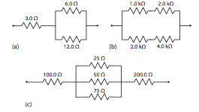
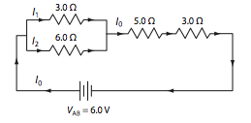
- Use the circuit above to answer the following:
  - What is the equivalent resistance of the circuit above?
  - What is the voltage across the 6.0 Ω resistor?

- A dry cell with an emf of 1.50 V has an internal resistance of 0.050 Ω. What is the terminal voltage of the cell when it is connected to a 2.00 Ω resistor?

- What is the emf of the battery if the current in A is 1.2 A and the internal resistance of the battery is 0.0833 Ω in this circuit?
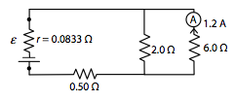
- What is the internal resistance of the battery shown here?
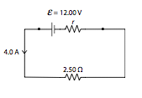
- A dry cell with an emf of 1.50 V and an internal resistance of 0.050 Ω Is “shorted out” with a piece of wire with a resistance of only 0.20 Ω. What will a voltmeter read if it is connected to the terminals of the dry cell at this time?

- A battery has an emf of 12.50 V. When a current of 35 A is drawn from it, its terminal voltage is 11.45 V. What is the internal resistance of the battery?

- A battery with an emf of 6.00 V has an internal resistance of 0.20 Ω. What current does the battery deliver when the terminal voltage reads only 5.00 V?
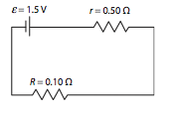
- The in the diagram above is short-circuited with a wire of resistance 0.10 Ω. What is the terminal voltage under these conditions?

Answers:

- a. 7.0 Ω b. 2000 Ω c. 314 Ω
- a. 10.0 Ω b. 1.2 V
- (1.46 V)
- (10 V)
- (0.50 Ω)
- (1.20 V)
- (0.030 Ω)
- (5.0 A)
- (0.25 V)

