Worksheet 7.2 Series and Parallel Circuits – Determining Voltage, Current and Resistance

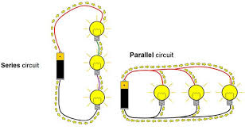
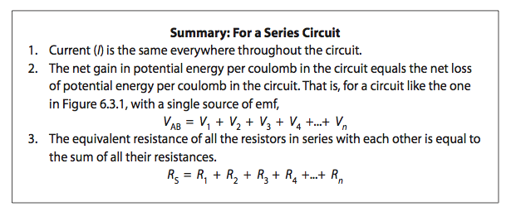
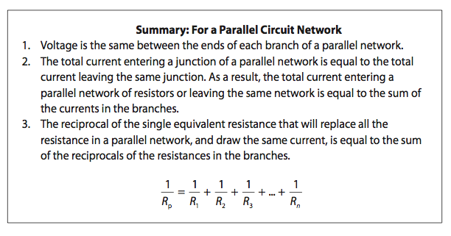

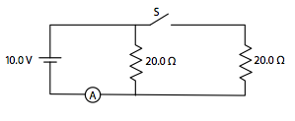
- The current through A is 0.50 A when the switch S is open. What will the current be through A when the switch S is closed?

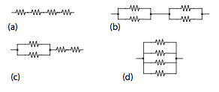
- Which one of the following arrangements of four identical resistors will have the least resistance?

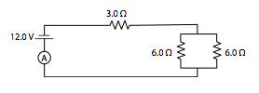
- What is the current in the ammeter A in this circuit?

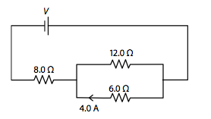
- What is the voltage V of the power supply in the circuit below?

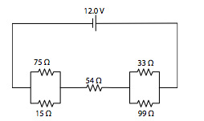
- Use this circuit diagram to answer the questions below.

  - What is the equivalent resistance of this circuit?
  - What is the current through the 54 Ω resistor?
  - How much power is dissipated in the 54 Ω resistor?

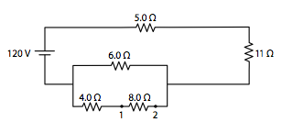
- Use this circuit diagram to answer the questions below.

- What is the voltage across the 8.0 Ω resistor (between 1 and 2)?
- How much power is dissipated in the 5.0 Ω resistor?

Answers:

- (1.0 A)
- (D)
- (2.0 A)
- (72 V)
- a. 91 Ω b. 0.13 A c. 0.93 W
- a. 16 V b. 180 W

