Worksheet - Electric Circuits (Ohm’s Law) and Resisters

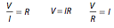

- A current of 3.60 A flows for 15.3 s through a conductor. Calculate the number of electrons that pass through a point in the conductor in this time.

- How long would it take 2.0x10²⁰ electrons to pass through a point in a conductor if the current was 10.0 A?

- Calculate the current if a charge of 5.60 C passes through a point in a conductor in 15.4 s.

- What is the potential difference across a conductor to produce a current of 8.00 A if there is a resistance in the conductor of 12.0 Ω?

- What is the heat produced in a conductor in 25.0 s if there is a current of 11.0 A and a resistance of 7.20 Ω?

- 150 J of heat are produced in a conductor in 5.50 s. If the current through the conductor is 10.0 A, what is the resistance of the conductor?

- What is the current through a 400 W electric appliance when it is connected to a 120 V power line?

- a. When an electric appliance is connected to a 120 V power line, there is a current through the appliance of 18.3 A. What is its resistance?

b. What is the average amount of energy given to each electron by the power line?

- a. What potential difference is required across an electrical appliance to produce a current of 20.0 A when there is a resistance of 6.00 Ω?

b. How many electrons pass through the appliance every minute?

- A student designed an experiment in order to measure the current through a resistor at different voltages. Given the following data:
a. Draw a graph showing the relationship between current and voltage
Voltage (V) | Current (I)
3.0 | 0.151
6.0 | 0.310
9.0 | 0.448
12.0 | 0.511
15.0 | 0.750

(V vs. I)

b. Using the graph, what is the resistance of the resistor?

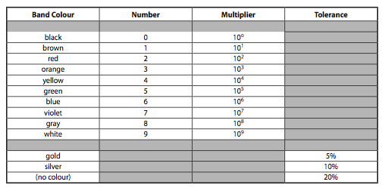

- What is the value of a resistor that has the colours gray, blue, red and silver?

- What is the value of a resistor that has the colours red, red, red and silver?

- What is the value of a resistor that has the colours brown, black, orange and gold?

- What is the value of a resistor that has the colours brown, green, green and silver?

- What is the value of a resistor that has the colours yellow, violet, and yellow?

Answers:

- (3.44x10²⁰)
- (3.2 s)
- (0.364 A)
- (96 V)
- (21 800 J)
- (0.273 Ω)
- (3.33 A)
- a. (6.56 Ω) b. (1.92x10⁻¹⁷ J)
- a. (120 V) b. (7.5x10²¹)
- b. (20.0 +/- 0.5 Ω)
- (8600 Ω ± 860 Ω)
- (2200 Ω ± 220 Ω)
- (10,000 Ω ± 500 Ω)
- (1 500 000 Ω ± 150 000 Ω)
- (470 000 Ω ± 94 000 Ω)

