**Waves and SHM: Springs and Pendulums**

/5

**Make sure to INCLUDE UNITS!**

1. Kangaroo shoes are shoes with spring attached to the bottom of them. An 80 kg person compresses the springs ***on each shoe***2.5 cm. What is the spring’s force constant on each shoe?
2. A block with a mass of 10 kg is placed on the end of a spring that is hung from the ceiling. When the block is attached to the spring, the spring is stretched out 20 cm from its rest position. The block is then pulled down an additional 5 cm and released. What is the block’s period of oscillation, and what is the speed of the block when it passes through its rest position?

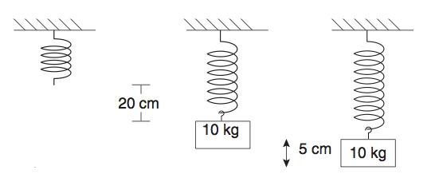

Answers:

1. 
2. 