**Waves and SHM: Resonance in Pipes**

/5

**Make sure to INCLUDE UNITS!**

1. For a pipe of length L = 1.84 m, what is the fundament frequency of the pipe if it is open at both ends?
2. A piano string is 1.10 m long and has a mass of 9.00 g.

HINT:  where μ = mass of a string divided by length!

1. How much tension must the sting be under if it is to vibrate at a fundamental frequency of 131 Hz?
2. What are the frequencies of the first four harmonics?

Answers:

1. For an open- open pipe  SAME as closed-closed.







1. 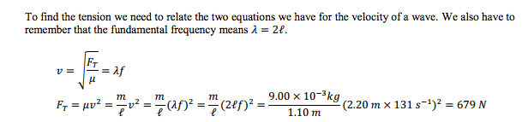

Note this quiz is a bit of a challenge! We will look at Simple Harmonic Motion next unit to review these concepts!