Waves and SHM: Sound and The Doppler Effect

/5

Make sure to INCLUDE UNITS!

- A honeybee is collecting pollen from a flower while flying stationary. The buzzing of a honeybee’s wings in emit at a frequency of 230 Hz. If you hear a bee buzzing at a frequency of 200 Hz while running in the garden, are you running towards or away from the honeybee?

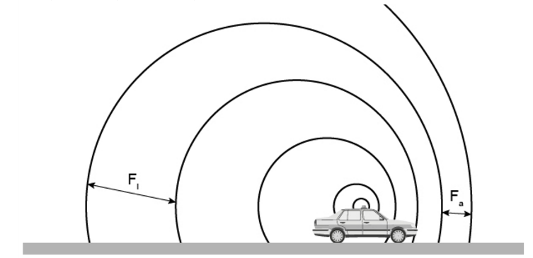

- As your drive past the high school practice field, your speedometer reads 20. mph (9.0 m/s). Driving away at the same speed, you see your coach jogging directly away from the car at a speed of 3.0 m/s and hear her blowing her whistle with a frequency you perceive to be 1.30 x10⁴ Hz. What would the frequency of the whistle be if you and your coach were standing still? The speed of sound is 343 m/s.

Answers:

- A honeybee is collecting pollen from a flower while flying stationary. The buzzing of a honeybee’s wings in emit at a frequency of 230 Hz. If you hear a bee buzzing at a frequency of 200 Hz while running in the garden, are you running towards or away from the honeybee?

Because the perceived pitch is lower than the actual pitch at that frequency, you must be running away.

- As your drive past the high school practice field, your speedometer reads 20. mph (9.0 m/s). Driving away at the same speed, you see your coach jogging directly away from the car at a speed of 3.0 m/s and hear her blowing her whistle with a frequency you perceive to be 1.30 x10⁴ Hz. What would the frequency of the whistle be if you and your coach were standing still? The speed of sound is 343 m/s.

