**Waves and SHM: Wave Properties**

/5

**Make sure to INCLUDE UNITS!**

1. Jasmine is pushing her little brother on a swing. The swing passes back and forth 14 times in 40 seconds.
   1. What is the frequency of the motion?
   2. What is the period of the swing?

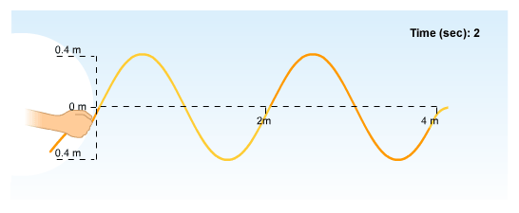

1. Redraw the wave and label a ***crest*** and a ***trough***. (1/2 mark each)
2. If the wave above takes 2.0 seconds to travel 4.0 meters find the following: (1/2 mark each)
   1. Wavelength
   2. Frequency
   3. Amplitude
   4. Speed of the wave

Answers:

1. Jasmine is pushing her little brother on a swing. The swing passes back and forth 14 times in 40 seconds.
   1. What is the frequency of the motion?



* 1. What is the period of the swing?





1. Redraw the wave and label a ***crest*** and a ***trough***. (1/2 mark each)
2. If the wave above takes 2.0 seconds to travel 4.0 meters find the following: (1/2 mark each)
   1. Wavelength – 2.0 m



* 1. Frequency – 1 Hz



* 1. Amplitude – 0.4 m



* 1. Speed of the wave – 2.0 m/s