Unit 5 – Waves: Quiz 5a

/5

- A concave shaving mirror has a focal length of 33 cm. Calculate the image position of a cologne bottle placed in front of the mirror at a distance of 93 cm. Calculate the magnification of the image. Is the image real or virtual? Is the image inverted or upright? Draw a ray diagram to confirm your result.

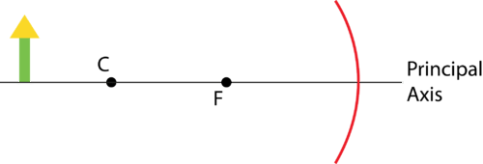

Answers:

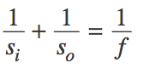 | 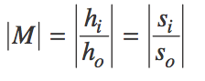

i = image o = object s = distance h = height M = magnification f = focal length

- s_{i} = 51 cm ; M = 0.55, real, inverted
