**Unit 5 – Waves: Quiz 3c**

/5

1. There was a major collision of an asteroid with the Moon in medieval times. It was described by monks at Canterbury Cathedral in England as a red glow on and around the Moon. How long after the asteroid hit the Moon, which is 3.84×105 km away, would the light first arrive on Earth?
2. 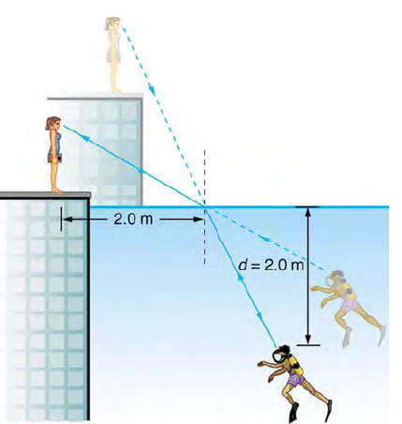A scuba diver training in a pool looks at his instructor as shown in the figure to the right. What angle does the ray from the instructor’s face make with the ***perpendicular*** to the water at the point where the ray enters? The angle between the ray in the water and the perpendicular to the water is 36.0º. (*n*water = 1.33 and *n*air = 1.0)

Answers:

1. There was a major collision of an asteroid with the Moon in medieval times. It was described by monks at Canterbury Cathedral in England as a red glow on and around the Moon. How long after the asteroid hit the Moon, which is 3.84×105 km away, would the light first arrive on Earth?





1. A scuba diver training in a pool looks at his instructor as shown in the figure to the right. What angle does the ray from the instructor’s face make with the ***perpendicular*** to the water at the point where the ray enters? The angle between the ray in the water and the perpendicular to the water is 36.0º. (*n*water = 1.33 and *n*air = 1.0)



