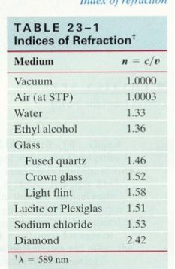**Unit 5 – Waves: Quiz 3b**

/5

1. The speed of light is slowed to 2.2 x 108 m/s when it travels from a vacuum to an unknown. Determine the unknown. ***Show your work!***
2. A 4.00 m long pole stands vertically in a lake having a depth of 2.50 m. If the Sun’s rays are 38.0° above the horizontal when the hit the water. Determine the length of the pole's shadow on the bottom of the lake.

Answers:



1. 



1. Shadow distance from the pole 

Now use Snell’s law to find the angle of refraction!

Initial angle = 900 – 380 = 520



Now we can see how far it travels in the water portion!







Total distance = 1.92m + 1.838 m = 3.758 m