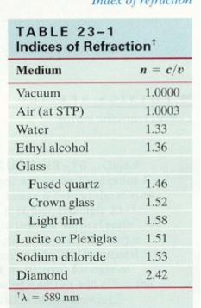**Unit 5 – Waves: Quiz 3a**

/5

1. Calculate the speed of light in diamond.
2. Light strikes a flat piece of **Crown glass** at an incident angle of 600.

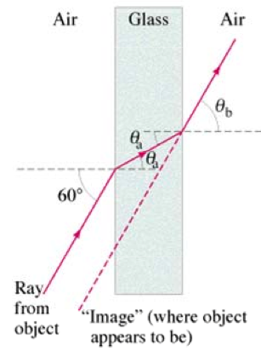

1. What is the angle of refraction θA in the glass?
2. What is the angle θB at which the ray emerges from the glass?

Answers:

1. 



1. 



1. 