Solutions Chem:
Shapes of Molecules (BEG): Quiz 3c

/5

Answer the following:

- CF₄
Electron Dot (Lewis) Structure
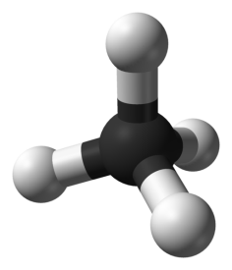

What is the geometry of this molecule? __________________________

Are the bonds Non-Polar, Polar, or Ionic? _______________________

- Complete the table below:

Molecule | 3D Structure | Bonding Pairs | Lone Pairs on Central Atom | Shape (name)
SF₆

Answers:

- CF₄
Electron Dot (Lewis) Structure
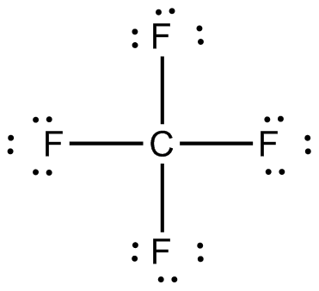

What is the geometry of this molecule? tetrahedral
Are the bonds Non-Polar, Polar, or Ionic? En = 1.5 ; Polar

- Complete the table below: (1/2 mark each)

Molecule | 3D Structure | Bonding Pairs | Lone Pairs on Central Atom | Shape (name)
SF₆ | 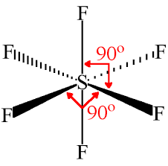 | 6 | 0 | Octahedral

