Worksheet 6.5 - Torque, Rotational Inertia, Angular Momentum and Kinetic Energy

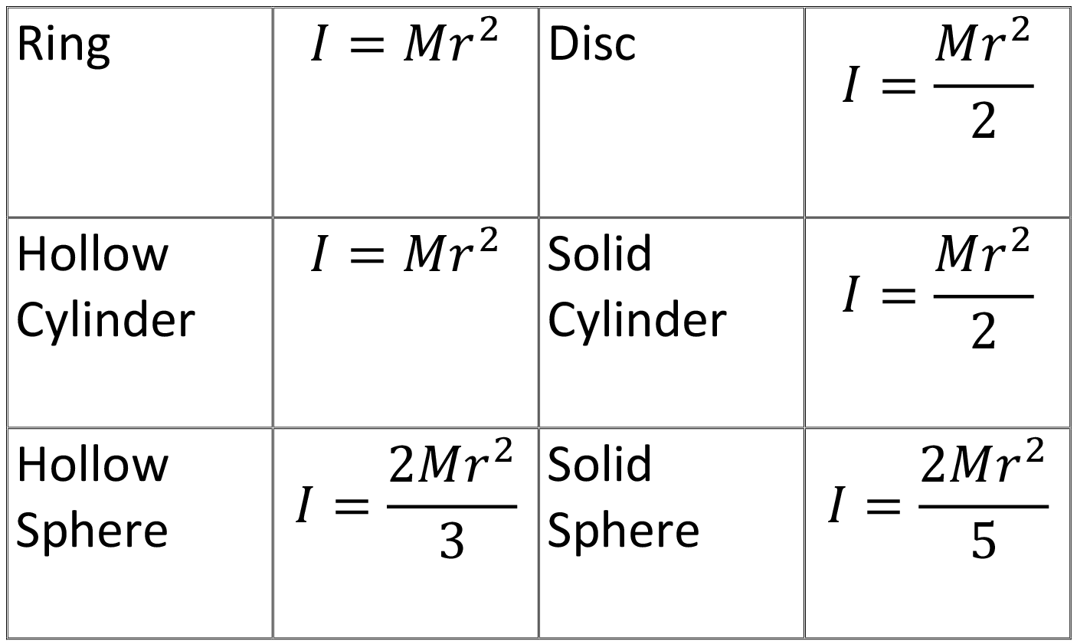
- When a torque of magnitude 32.0 N·m is applied to a certain wheel, it acquires an angular acceleration of 25.0 rad/s². What is the moment of inertia of the wheel?

- A flywheel (disk) initially spinning at 1850 rpm counterclockwise is brought to rest in 3.00 minutes.
  - What is the wheel’s average angular acceleration?
  - What is the angular displacement of the flywheel during this acceleration?
  - If the flywheel has a mass of 155 kg and a radius of 0.650 m, what torque was required to accelerate it?

- A heavy flywheel rotating counterclockwise about its middle at an original speed of 157.1 rad/s is slowing down because of friction in its bearings.
  - If its acceleration is constant at 1.785 rad/s², find its angular velocity at the end of 1.00 minute.
  - The flywheel is 5.50 m in diameter and has a mass of 985 kg. If the flywheel resembles a uniform disk, find the torque applied by friction.

- A uniform solid sphere has a mass of 1.765 kg and a radius of 0.854 m.
  - Find the torque required to bring the sphere from rest to an angular velocity of 317 rad/s, clockwise, in 15.5 s.
  - What magnitude force applied tangentially at the equator would provide the needed torque?

- A piece of machinery with a moment of inertia of 2.5 kg∙m² rotates with a constant angular speed of 4.0 rad/s. A bolt loosens, causing a part of it to shift outward from the rotation axis, increasing the moment of inertia by 1.0 kg∙m². What would the new angular speed of the machinery be?

- A small particle of mass 0.20 kg is being whirled in a horizontal circle at the end of a 2.0 m long string at a constant speed of 1.0 m/s. Determine its angular momentum about its axis of rotation.

- A bowling ball has a mass of 5.5 kg and a radius of 12.0 cm. It is released so that it rolls down the alley at a rate of 12 rev/s. Find the magnitude of its angular momentum.

- a. What is the angular momentum of a 2.8 kg uniform cylindrical grinding wheel of radius 18 cm when rotating at 1500 rpm? b. How much torque is required to stop it in 6.0 s?

- Calculate the moment of inertia of a wheel that has a rotational kinetic energy of 24,400 J when it is rotating at 62.8 rad/s.

- A man stands on a rotating platform that has an angular speed of 6.28 rad/s; his arms are outstretched and he holds a weight in each hand. With his hands in this position the total moment of inertia of the man, the weights, and the platform is 6.00 kg·m². If by moving the weights the man decreases the total moment of inertia to 2.00 kg·m².
  - What is the resulting angular speed of the platform?
  - By how much is the kinetic energy increased?’

Answers:

- 1.28 kg·m²
- a. 1.08 rad/s² b. 17,400 rad c. 35.4 N⋅m
- a. 50.0 rad/s b. 6650 N·m,
- a. 10.5 N·m, in b. 12.3 N
- 2.9 rad/s Remember Momentum (even angular!) is Conserved
- 0.40 kg·m²/s
- 2.4 kg·m²/s
- a. 7,1 kg·m²/s b. 1.2 N
- 12.4 kg·m²
- a. 18.8 rad/s b. 235 J

