Solutions Chem:
Shapes of Molecules (ADV): Quiz 3c

/5

Answer the following:

- Complete the table below:

Molecule | 3D Shape (draw it!) | Bonding Pairs | Lone Pairs on Central Atom | Name | Polar or Non-Polar
BrF₅

*Double Bonds are treated as single bonds for repulsion purposes!

Answers:

- Complete the table below:

Molecule | 3D Shape (draw it!) | Bonding Pairs | Lone Pairs on Central Atom | Name | Polar or Non-Polar
BrF₅ | 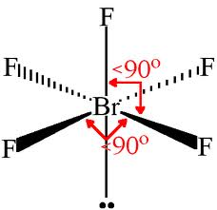 | 5 | 1 | Square Pyramidal | Polar

*Double Bonds are treated as single bonds for repulsion purposes!

