Solutions Chem:
Shapes of Molecules (ADV): Quiz 3a

/5

Answer the following:

- Complete the table below:

Molecule | 3D Shape (draw it!) | Bonding Pairs | Lone Pairs on Central Atom | Name | Polar or Non-Polar
I₃⁻¹

*Double Bonds are treated as single bonds for repulsion purposes!

Answers:

- Complete the table below:

Molecule | 3D Shape (draw it!) | Bonding Pairs | Lone Pairs on Central Atom | Name | Polar or Non-Polar
I₃⁻¹ | 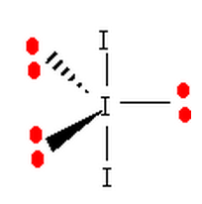 | 2 | 3 | Linear | Non-Polar

*Double Bonds are treated as single bonds for repulsion purposes!

