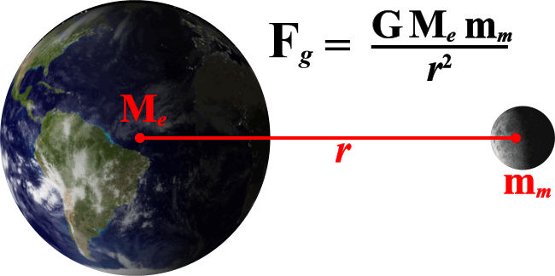
Worksheet 5.3 - Newton’s Gravitational Law

m_{Earth} = 5.98x10²⁴ kg m_{Moon} = 7.35x10²² kg

- Calculate the value of g at each of the locations in the table below. Express each answer as a multiple or decimal fraction of Earth’s g. Would the force of gravity on you be greatest on the Moon, on Ganymede (*one of Jupiter’s Moons), or on Mercury?

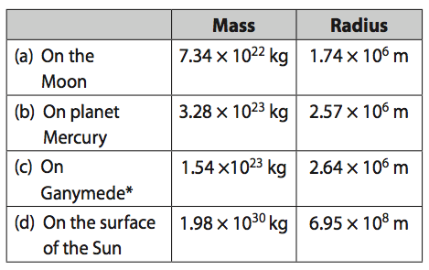

- Two students are sitting 1.50 m apart. One student has a mass of 70.0 kg and the other has a mass of 52.0 kg. What is the gravitational force between them?
- What gravitational force does the moon produce on the Earth if their centers are 3.84x10⁸ m apart?
- If the gravitational force between two objects of equal mass is 2.30x10⁻⁸ N when the objects are 10.0 m apart what is the mass of each object?

- Calculate the gravitational force on a 6.50x10² kg spacecraft that is 4.15x10⁶ m above the surface of the Earth.
- The gravitational force between two objects that are 2.1x10⁻¹ m apart is 3.2x10⁻⁶ N. If the mass of one object is 55 kg, what is the mass of the other object?

- If two objects, each with a mass of 200 kg, produce a gravitational force of 3.7x10⁻⁶ N, what is the distance between them?

- What is the gravitational force on a 70.0 kg object standing on the Earth’s surface?
- Three 10.0 kg objects are placed in a straight line 5.00x10-1 m apart. What is the net gravitational force on the center object due to the other two objects?
- Three objects A, B, and C are placed 0.50 m apart along a straight line. A and B have masses of 10.0 kg and C has a mass of 15.0 kg, what is the net gravitational force on B due to A and C?
B
C
A

- The force of gravity between two small masses A and B when placed very near each other is 3.24x10⁻⁷ N. What will the force between these objects be if both of their masses are doubled and the distance between them is tripled?

Answers:

- a. 1.62 m/s² or 0.17g b. 3.31 m/s² or 0.34g c. 1.47 m/s² or 0.15g d. 273 m/s² or 28 g (Weird right!?)
- (1.08x10-⁷ N)
- (1.99x10²⁰ N)
- (186 kg)
- (2.34x10³ N)
- (38 kg)
- (0.85 m)
- (686 N)
- (0N)
- (1.33x10⁻⁸ N)
- (1.44x10⁻⁷ N)

