Worksheet 5.2 – Centripetal Force and Acceleration II
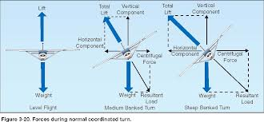

- You are riding your bike on a track that forms a vertical circular loop. If the diameter of the loop is 10.0 m, what is the minimum speed required for you to make it around the loop?

- You are swinging a bucket of water in a vertical circle. Assuming that the radius of the rotation of the water is 0.95 m, what is the minimum velocity of the bucket at the top of its swing if the water is not to spill?

- A student has a weight of 655 N. While riding a roller coaster they seem to weigh 1.96x10³ N at the bottom of a dip that has a radius of 18.0 m. What is the speed of the roller coaster at this point?

- A string requires 186 N of force to break. A 1.50 kg mass is tied to the string and whirled in a vertical circle with a radius of 1.90 m. What is the maximum speed that this mass can be whirled at without breaking the string?

- A 2.2 kg object is whirled in a vertical circle whose radius is 1.0 m. If the time of one revolution is 0.97 s, what is the tension in the string (assume uniform speed)
a) at the top?
b) at the bottom?

- 6) A 915 kg car goes over a hill of circular arc. If the radius of the curve is 43 m, how fast can the car travel without leaving the road at the top of the arc?
- 7) What is the maximum speed for a car rounding a 125 m curve on a highway under very icy (no friction) conditions if the banking angle is 20.0º.

- A roller coaster loop has a radius of 12 m. To prevent the passengers in a car from not falling out at the top of the loop, what is the minimum speed the car must have at the top?

- Tarzan is swinging through the jungle on a vine that will break if the force exceeds 2.0 x 10³ N. If the length of the vince is 5.0 m and Tarzan’s mass is 100. kg, what is the highest speed he can safely travel while swinging on the vine? HINT: At what point in the swing will the tension in the vine be the greatest?

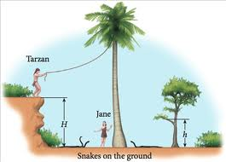

SPECIAL!) An airplane traveling at a speed of 115 m/s makes a complete horizontal turn in 2 minutes. What is the banking angle?

Answers:

- (7.00 m/s)
- (3.1 m/s)
- (18.8 m/s)
- (14.7 m/s)
- a. 71 N b. 114 N
- (21 m/s)
- (21.1 m/s)
- 11 m/s
- 7.1 m/s

Special! (31.6º to the horizontal))

