Ideal Gas Processes and the 1st Law of Thermodynamics Name: ________________________

Show your work.

Let’s investigate two thermodynamic systems.

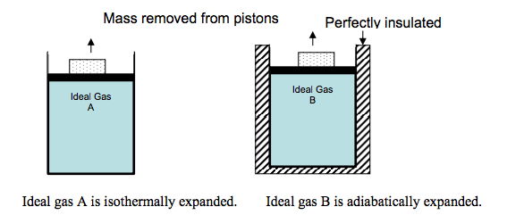
In the figure above, two cylinders are filled with the same ideal gas. A piston is fit so that no gas escapes; friction is negligible between the piston and the cylinder walls. The block is removed from each piston, the piston moves upward.

- In each case, does the gas do work or is work done on the gas? Explain your reasoning in a few sentences.

In both A and B, the gas expands against the surroundings. Work is done on the surroundings (W<0) because the external pressure suddenly decreases as the weight is removed from the piston and the gas expands to match the external pressure.

- Is there a larger transfer of thermal energy as heat between Gas A and the surrounding or between Gas B and the surroundings? Explain your reasoning in a few sentences. Draw an arrow on each figure indicating the direction of thermal energy flow.

There is a larger transfer of thermal energy as heat between Gas A and the surroundings because it is an isothermal expansion. In order to compensate for work being done isothermally on the surroundings, thermal heat must enter the system to maintain the temperature of the expanding system. Arrow: pointed into the system!! There is NO transfer of thermal energy as heat between Gas B and the surroundings because it is a well-insulated system and by definition heat cannot flow into or out of the system. Therefore, the temperature of the system decreases. Arrow: There is not an arrow!!

- For the expansion of Gas A, how do the work and heat involved in this process affect the internal energy of the gas? Explain your reasoning in a few sentences.
ΔU = 0 and W = -Q.

There is no temperature change in an isothermal process; therefore, the ΔU = 0 and W = -Q.
The system does work on the surroundings and the work is compensated by heat from the surroundings. work out = - heat in

- For the expansion of Gas B, how do the work and heat involved in this process affect the internal energy of the gas? Explain your reasoning in a few sentences.

Q = 0 and ΔU = W

This is an adiabatic process; therefore, Q = 0 and ΔU = W. Since the system does work on the surroundings, work < 0 and the internal energy decreases which corresponds to a decrease in the temperature.

We will now investigate a real-life example!
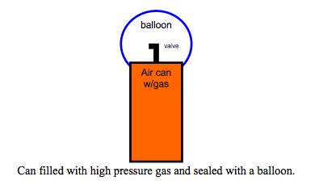
Use the figure above to make a prediction.

- What happens to the temperature of the gas inside the can as you allow the gas to expand into the balloon?

The temperature of the gas decreases because you are expanding the gas.

- Why does this temperature change occur? Explain the reasoning for your answer in a few sentences.

Note: Consider the system to be the balloon, the can, and the gas, everything outside of the can and balloon is considered the surroundings. There is NO loss of gas molecules during this expansion.

This is an ~ adiabatic expansion. Work is done on the surroundings, but no heat (initially) enters the system. U = Q + W (where Q=0), so U = Q. If work is done on surroundings (W < 0), then the internal energy must decrease, and therefore the T decreases: ΔU=C_{V}ΔT or W_{ad} = C_{V}ΔT

Now test your prediction with one of the air cans at the front of the room and make any necessary corrections to your answers above.

- Initially (within the first minute of the expansion), is this example more like an isothermal expansion or an adiabatic expansion? Explain the reasoning for your answer in a few sentences.

This is like an adiabatic expansion. The expansion happens much faster than the transfer of thermal energy between the system and the surroundings. Even though the can is not insulated, the expansion is quick and the transfer of thermal energy as heat is slow to enter the can and restore the temperature to that of the surroundings.

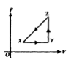
- A thermodynamic system is taken from an initial state X along the path XYZX as shown in the PV-diagram to the right.

  - For the process X Y, ΔU is greater than zero and

    - Q < 0 and W = 0
    - Q < 0 and W > 0
    - Q > 0 and W < 0
    - Q > 0 and W = 0
    - Q > 0 and W > 0

  - For the process Y Z, Q is greater than zero and

    - W < 0 and ΔU = 0
    - W = 0 and ΔU < 0
    - W = 0 and ΔU > 0
    - W > 0 and ΔU = 0
    - W > 0 and ΔU > 0

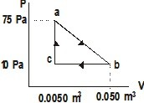
- A gas undergoes a thermodynamic expansion process as shown. Process ab represents the output work, process bc represents input work, all three processes involve heat transfer. (a) what is the work accomplished along path ca?
- 0 J
W = -PΔV = -P 0 = 0 J

(b) What is the work along path ab,

- W = -PΔV
= -42.5 Pa 0.045 m³ = -1.91 J or 1.91 J work done by system

(c) What is the work along path bc?

- W = -PΔV
= -10 Pa (-0.045 m³) = 0.45 J or 0.45 J work done on system

(d) What is the net work for the entire thermo cycle?

- Wnet = Wout + Win = -1.91 J + 0.45 J = -1.46 J or 1.46 J work done by system

