Ideal Gas Processes and the 1st Law of Thermodynamics Name: ___________________

Show your work.

Let’s investigate two thermodynamic systems.

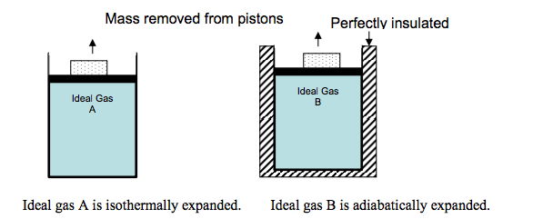
In the figure on the front of the page, two cylinders are filled with the same ideal gas. A piston is fit so that no gas escapes; friction is negligible between the piston and the cylinder walls. The block is removed from each piston, the piston moves upward.

- In each case, does the gas do work or is work done on the gas? Explain your reasoning in a few sentences.

- Is there a larger transfer of thermal energy as heat between Gas A and the surrounding or between Gas B and the surroundings? Explain your reasoning in a few sentences. Draw an arrow on each figure indicating the direction of thermal energy flow.

- For the expansion of Gas A, how do the work and heat involved in this process affect the internal energy of the gas? Explain your reasoning in a few sentences.

- For the expansion of Gas B, how do the work and heat involved in this process affect the internal energy of the gas? Explain your reasoning in a few sentences.

We will now investigate a real-life example!
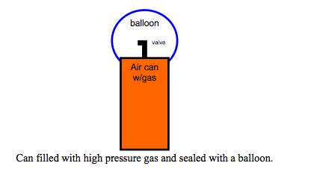
Use the figure above to make a prediction.

- What happens to the temperature of the gas inside the can as you allow the gas to expand into the balloon?

- Why does this temperature change occur? Explain the reasoning for your answer in a few sentences.

Note: Consider the system to be the balloon, the can, and the gas, everything outside of the can and balloon is considered the surroundings. There is NO loss of gas molecules during this expansion.

Now test your prediction with one of the air cans at the front of the room and make any necessary corrections to your answers above.

- Initially (within the first minute of the expansion), is this example more like an isothermal expansion or an adiabatic expansion? Explain the reasoning for your answer in a few sentences.

Ideal Gas Processes

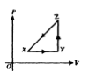
- A thermodynamic system is taken from an initial state X along the path XYZX as shown in the PV-diagram to the right.

  - For the process X Y, ΔU is greater than zero and

    - Q < 0 and W = 0
    - Q < 0 and W > 0
    - Q > 0 and W < 0
    - Q > 0 and W = 0
    - Q > 0 and W > 0

  - For the process Y Z, Q is greater than zero and

    - W < 0 and ΔU = 0
    - W = 0 and ΔU < 0
    - W = 0 and ΔU > 0
    - W > 0 and ΔU = 0
    - W > 0 and ΔU > 0

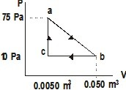
- A gas undergoes a thermodynamic expansion process as shown. Process ab represents the output work, process bc represents input work, all three processes involve heat transfer.

- What is the work accomplished along path ca?
- What is the work along path ab,
- What is the work along path bc?
- What is the net work for the entire thermo cycle?

