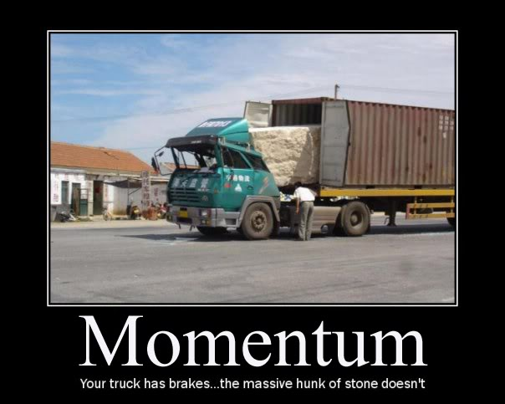
Worksheet 4.4 – Collisions/Explosions!

Set up each problem by drawing a CLEAR diagram. Use a ruler, include all values and angles.

Remember when a collision is INELASTIC kinetic energy is NOT conserved.

- A 60.0 kg hockey player travelling 2.0 m/s toward the north collides with a 50.0 kg player traveling 1.0 m/s toward the west. The two become tangled together. With what velocity will they move after the collision?
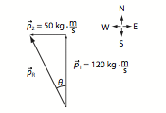
- A 0.050 kg air puck moving with a velocity of 2.0 m/s collides with an identical but stationary air puck. The direction of the incident puck is changed by 60º from its original path and the angle between the two pucks after the collision is 90 º. What are the speeds of the two pucks after they collide?

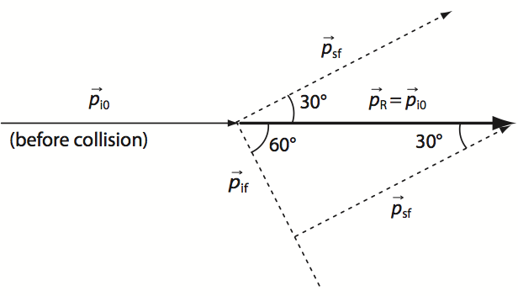

- A 1.4 x 10³ kg car is westbound at a velocity of 37.0 km/h when it collides with a 2.0 x 10³ kg truck northbound at a velocity of 35 km/h. If these two vehicles lock together upon collision, what is the initial velocity of the vehicles after collision?

- A 6.2 kg object heading north at 3.0 m/s collides with an 8.0 kg object heading west at 3.5 m/s. If these two masses stick together upon collision, what is their velocity after collision?

- A 4.0 x 10⁴ N Truck moving west at a velocity of 8.0 m/s collides with a 3.0 x 10⁴ N truck heading south at a velocity of 5.0 m/s. If these two vehicles lock together upon impact, what is their velocity?

- A 50.0 kg object is moving east at an unknown velocity when it collides with a 60.0 kg stationary object. After collision, the 50.0 kg object is traveling at a velocity of 6.0 m/s 50.0º N of E and the 60.0 kg object is traveling at a velocity of 6.3 m/s 38º S of E.
  - What was the velocity of the 50.0 kg object before collision?
  - Determine whether this collision was elastic or inelastic.

- A 15.0 kg penguin waddling east at a velocity of 7.0 m/s collides with a stationary 10.0 kg penguin. After the collision the 15.0 kg penguin is traveling at a velocity of 4.2 m/s 20.0º S of E.
  - What is the velocity of the 10.0 kg penguin after collision?
  - Is this collision elastic or inelastic?

- A watermelon explodes into three equal masses. One mass moves east at 15.0 m/s. If a second mass moves at a velocity of 10.0 m/s 45.0º S of E, what is the velocity of the third mass? (Hint: the total momentum is zero, so how will your vector arrows add up?)

SPECIAL – at this point of the year this is probably how you feel about your infamous Physics 12 teacher!

Mr. Lawson’s head explodes into three pieces after thinking too hard about this very problem (but HOW!?). As we all know, Mr. Lawson’s head has a mass of 15kg (that’s a lot of physics up there). A 6.0 kg chunk flies off at 12.0 m/s 15º N of W and a 5.0 kg chunk sails at 8.0 m/s 35º E of S. What is the velocity of the final piece?

Answers:

- v_{r} = 1.2 m/s 22.6º W of N
- 1.0 m/s and 1.7 m/s
- (7.2 m/s 37º W of N)
- (2.4 m/s 56º W of N)
- (5.0 m/s 25º S of W)
- (9.86 m/s due east) (Ek loss of 340 J, so inelastic)
- (5.1 m/s 25º N of E) (Inelastic, E_{k} loss of 110J)
- (23.2 m/s 18º N of W)

Special: 4.0 kg piece 12.2 m/s 17º N of W

