Thermodynamics: Efficency Name: _________________________________

- Thermodynamics efficiency is dependent upon which two parameters?

- Write the temperature version of the equation for calculating thermodynamic efficiency.

- For all intents and purposes, what temperature should you use for the temperature of the heat sink for a heat engine on Earth?

- When calculating thermodynamic efficiency, what temperature scale must you use? How do you convert from this scale to the Celsius temperature scale?

- Obviously the environmental temperature of a power plant changes seasonally. The table below, provide relevant data for four types of power plants, a pulverized coal plant (PC), a supercritical pulverized coal (SCPC), and two of the most common types of light water nuclear reactors (pressurized (PWR) and boiling (BWR) water). Use this data to calculate how the thermal efficiencies of these plants change seasonally.

 | Operating Conditions |  | Outdoor  Temperature (ºC) | Theoretical  Efficiency (%) | Observed  Efficiency (%)
Plant | Temperature (⁰C) | Pressure (psi)
PC | 325 |  | 29 |  | 30‐35
 |  |  | 8
SCPC | 600 |  | 29 |  | ?
 |  |  | 8
PWR | 317 | 2235 | 29 |  | 32
 |  |  | 8
BWR | 286 | 1050 | 29 |  | 32
 |  |  | 8

- How does a power plant make up for this different in thermodynamic efficiency?

- One use of thermodynamics efficiency to is compare proposed new technologies to existing ones and determine how much better they might be. Currently, GENII nuclear reactors cannot operate at very high temperatures. To improve their thermal efficiency, GENIV reactors are being designed to run at very much higher temperatures. Use the data in the table below to calculate what the gain may be going from two GENII reactors (CANDU – CANadian Deuterium Uranium) and AGR – advanced gas‐cooled ) to two new GENIV reactors (VHTR – very high‐ temperature and GFR – gas‐cooled fast).

 | Operating conditions |  | Outdoor  Temperature (oC) | Theoretical  Efficiency (%) | Observed  Efficiency (%)
Plant | Temperature (ºC) | Pressure (psi)
AGR | 650 | 600 | 15 |  | 42
CANDU | 305 | 1000 | 15 |  | 30
VHTR | 1000 | high | 15 |  | ?
GFR | 850 | high | 15 |  | ?

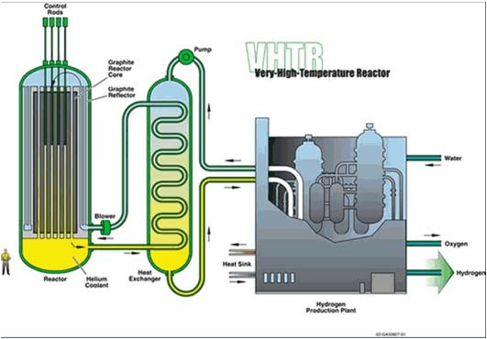
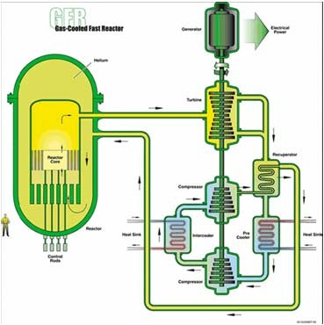
VHTR: electricity, hydrogen GFR: electricity, hydrogen

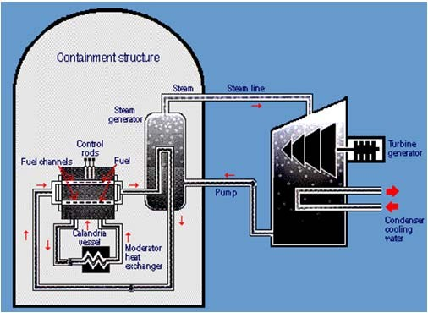
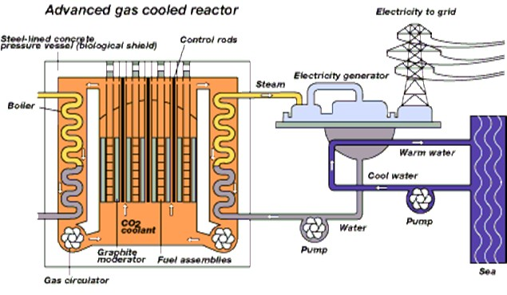
CANDU AGR

