Worksheet 3.2 – Buoyancy

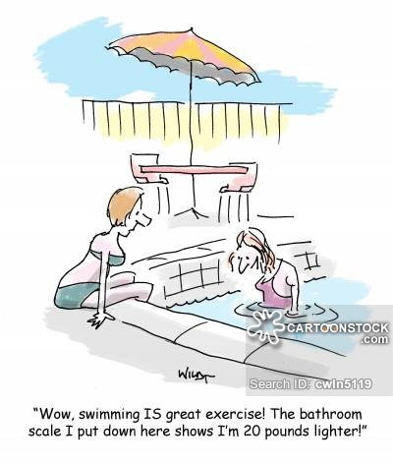
Show ALL WORK including knowns and steps taken to solve the problem!

Substance | ρ(kg/m³) | Substance | ρ(kg/m³)
Ice | 0.917 x 10³ | Water | 1.00 x 10³
Aluminum | 2.70 x 10³ | Salt Water | 1.025 x 10³
Iron | 7.86 x 10³ | Glycerin | 1.26 x 10³
Copper | 8.92 x 10³ | Ethyl Alcohol | 0.806 x 10³
Silver | 10.5 x 10³ | Benzene | 0.879 x 10³
Lead | 11.3 x 10³ | Mercury | 13.6 x 10³
Gold | 19.3 x 10³ | Air | 1.29
Platinum | 21.4 x 10³ | Oxygen | 1.43
Uranium | 18.7 x 10³ | Hydrogen | 8.99 x 10⁻²
Brass | 8.7 x 10³ | Helium | 1.79 x 10⁻¹

- Day to day Atmospheric pressure varies. A floating ship will be a. higher b. lower or c. no different on a low-pressure day versus a high-pressure day?

- The density of Silver is greater than Copper. If you had an objects of Copper and Silver of the same dimensions and placed them in water… Would the buoyant force (F_{b})
  - be greater on Silver than Copper
  - be smaller on Silver than Copper
  - equal for Silver and Copper

- A submarine with mass m rests on the sea bottom. The normal force exerted up on the sub by the sea-floor is equal to:
  - Mg
  - ρ_{w}gV_{w}
  - mg + ρ_{w}gV_{w}
  - mg - ρ_{w}gV_{w}
  - ρ_{w}gV_{w} – 1 atm

- A spherical inflated balloon is submerged in a pool of water. If it is further inflated so that its radius doubles, how is the buoyant force affected?
- not at all
- 2 times larger
- 4 times larger
- 6 times larger
- 8 times larger

- Six objects (A-F) are in a liquid, as shown. None of them are moving. Arrange them in order of density, from lowest to highest.
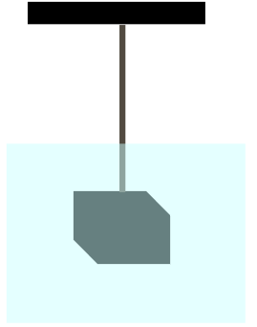
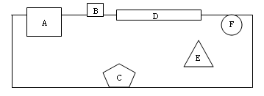
- A 2.00 kg brass block is attached to a string and submerged underwater. Find the buoyant force and the tension in the rope. A FBD might help!

- A weather balloon (with a spherical shape) is filled with helium until its radius is 3.00 m. Its total mass including instruments is 20.0 kg.
  - Find F_{b}.
  - Find the F_{net} when the ball is released.
  - What happens to the radius of the balloon as it rises to a higher altitude? Increase/Decrease/Stay’s the same

Answers:
- C
- C
- D 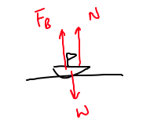
- E (V ~ r³)
- B, D, A, F, E, C.
The more of an object's volume is above the water surface, the less dense it is. Object B must therefore be the least dense, followed by D, A, and F. Object E is next, because it is neutrally buoyant and equal in density to the liquid. Object C is negatively buoyant because it is more dense than the fluid.
- F_{b} + T = mg ; F_{b} = 2.25 N ; T = 17.3 N
- a. 1.43 x 10³ N b. 1.04 x 10³ N c. Increase

