Worksheet 3.1 – Density and Pressure

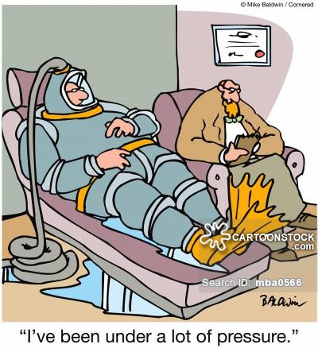
Show ALL WORK including knowns and steps taken to solve the problem!
Substance | ρ(kg/m³) | Substance | ρ(kg/m³)
Ice | 0.917 x 10³ | Water | 1.00 x 10³
Aluminum | 2.70 x 10³ | Salt Water | 1.025 x 10³
Iron | 7.86 x 10³ | Glycerin | 1.26 x 10³
Copper | 8.92 x 10³ | Ethyl Alcohol | 0.806 x 10³
Silver | 10.5 x 10³ | Benzene | 0.879 x 10³
Lead | 11.3 x 10³ | Mercury | 13.6 x 10³
Gold | 19.3 x 10³ | Air | 1.29
Platinum | 21.4 x 10³ | Oxygen | 1.43
Uranium | 18.7 x 10³ | Hydrogen | 8.99 x 10⁻²
Brass | 8.7 x 10³ | Helium | 1.79 x 10⁻¹
- Suppose you have one cubic meter of gold, two cubic meters of silver, and six cubic meters of aluminum. Rank them by mass, from largest to smallest.
  - Gold, Aluminum, Silver
  - Silver, Gold, Aluminum
  - Aluminum, Gold, Silver
  - Silver, Aluminum, Gold

- What is the mass of a solid iron wrecking ball with a radius of 18 cm?

- Substance A has a density of 3 g/cm³ and substance B has a density of 4 g/cm³. In order to obtain equal masses of these substances, the ratio of the volume of A to the volume of B will be equal to…

- 1:3 | - 4:3 | - 3:4 | - 1:4 | - 1:2
- A waterbed has the following dimensions 2.00 m x 2.00 m and 30.0 cm deep.
  - Find its weight.
  - Find the pressure that the waterbed exerts on the floor.

- The density of the salt water in the Dead Sea is extremely high (1.240 x 10³ kg/m³) due to the high concentration of salt. So high in fact it becomes extremely easy to float!
  - What hydrostatic pressure exists at a depth of 30.0 m beneath the Dead Sea?
  - At what depth will the hydrostatic pressure be 100.0 kPa?

- The Titanic was found in 1985 lying at the bottom of the North Atlantic at a depth of 4 kilometers. What is the pressure at this depth?

- Calculate the force exerted on an eardrum that has a cross-sectional area of 5.0x10⁻⁵ m², when the swimmer is at the bottom of a freshwater pool 6.0 m deep.

- Four acrobats of mass 66.0 kg, 68.0 kg, 63.0 kg and 55.0 kg for a tower of humans! Each acrobat stands on the shoulders of another acrobat with the 68.0 kg acrobat at the bottom.
  - Find the normal force acting on the 68.0 kg acrobat.
  - Find the pressure the acrobats exert on the ground if each of the acrobats shoes are approximately 415 cm².
  - The 55.0 kg acrobat is shifted to the bottom and the human tower is reformed! Calculate the pressure exerted on the floor.

- A car lift is used at a local garage; compressed air exerts a force on a small circular piston having a radius of 4.00 cm. This pressure is transmitted across an incompressible liquid to the second circular piston that is 16.0 cm.
  - What force must be exerted on the small piston in order to lift a car with a mass of 2360 kg? (Neglect the weight of the pistons)
  - What air pressure will produce a force of this size?

Answers:

- B
- 190 kg
- B ()
- a. 1.18 x 10⁴ N b. 2.95 x 10³ Pa
- a. 365 kPa b. 8.2 m
- P = 4.01 x 10⁷ Pa
- Pressure = 5.88 x 10⁴ Pa ; Force = 2.9 N
- a. 2470 N b.
- a. 1450 N ; b. 1.84 x 10⁵ Pa OR 184 kPa

