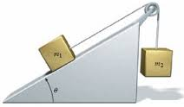

Worksheet 2.4 - Two Objects with an Incline

- In the diagram below, a cord of negligible mass connects a 0.500 kg mass to a 1.00 kg mass. Friction is negligible. (Not really an incline but a great question to start with!)
  - At what rate will the mass accelerate?
  - What is the tension in the cord while the masses are accelerating?
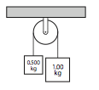

- Two blocks are tied together with a string as shown.

If both the pulley and incline are frictionless find
m₂ = 1.0 kg
m₁ =
2.0 kg
30º

- the direction and magnitude of acceleration on
the 1.0 kg mass.

- the tension in the string joining the blocks.

- If the ramp and block in question 1 have a coefficient of friction of 0.135, what will be the block’s acceleration?

- Two boxes, m₁ = 1.0 kg with a coefficient of friction of 0.10, and m₂ = 2.0 kg with a coefficient of 0.20, are placed on a plane at 30º above the horizontal.

- What acceleration does each block experience?
- If a taut string connects the blocks, with m₂ initially further down the incline then m₁, what is the acceleration of each block?
- In the initial acceleration is reversed with m₁ starting lower with a taut string, what is the acceleration of each block?

- What is the magnitude of acceleration of the masses in the diagram below? (frictionless system)

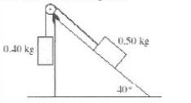

- Two masses are connected together by a rope and pulley on a frictionless incline plane as shown:
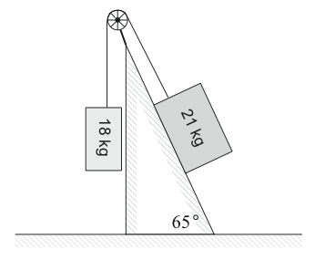
When the system is released, what is the initial acceleration (magnitude and direction) of the 21 kg mass?

- Two packing crates of masses 10.0 kg and 5.00 kg are connected by a light string that passes over a frictionless pulley. The 5.00-kg crate lies on a smooth incline of angle 40.0°. Find the acceleration of the 5.00-kg crate and the tension in the string.
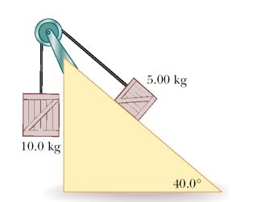
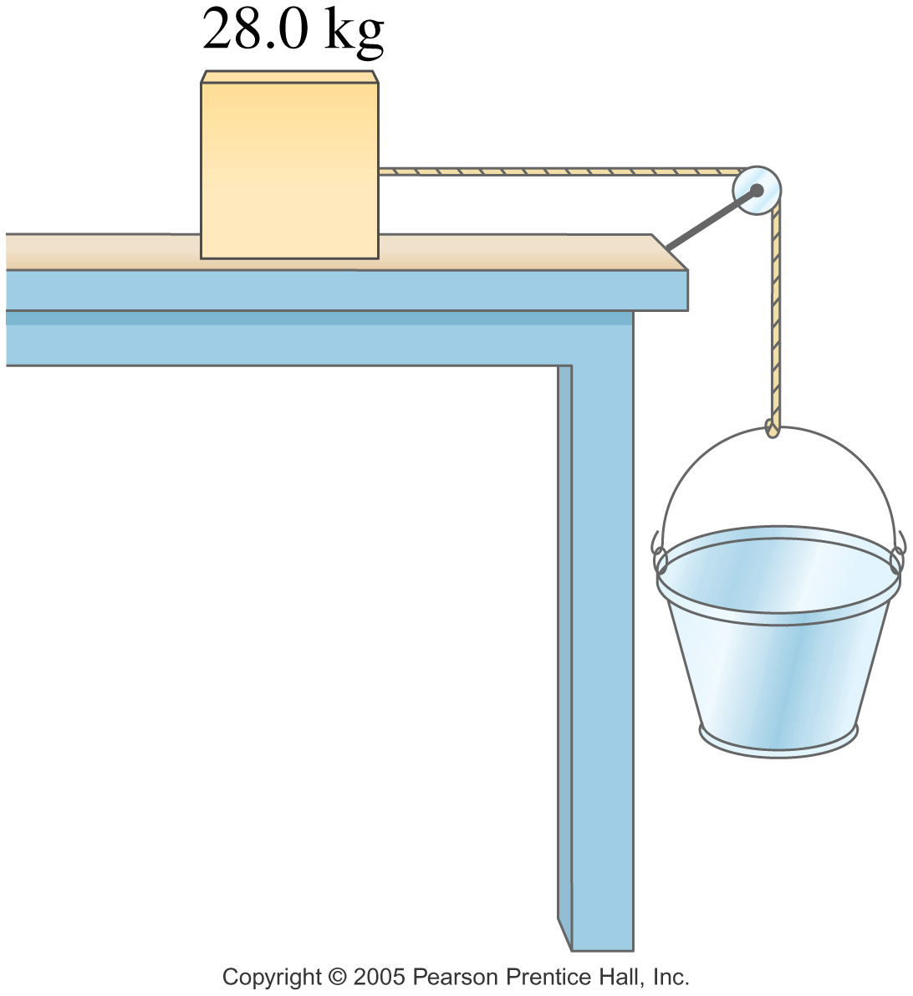
- A 28.0-kg block is connected to an empty 1.35-kg bucket by a cord running over a frictionless pulley. The coefficient of friction between the table and the block is 0.320. Sand is gradually added to the bucket until the system just begins to move. (a) Calculate the mass of sand added to the bucket. (b) Calculate the acceleration of the system if 8.00 kg were added to the system.

Answers:

- a. 3.3 m/s² b. 6.5 N, No
- a. 4.9 m/s² up the ramp b. 9.8 N
- 4.5 m/s²
- a. 4.1 m/s², 3.2 m/s² b. a₁ = 4.1 m/s², a₂ = 3.2 m/s² c. 3.5 m/s²
- 0.86 m/s²
- 0.26 m/s² down the incline
- a. 4.43 m/s² F = 53.7 N
- a. 7.61 kg b. 0.102 m/s²

