Worksheet 2.3 - Complete on a separate piece of paper! Draw a free body diagram for EACH of the following. Include all the known values and show ALL work (including a lead equation that demonstrates understanding)
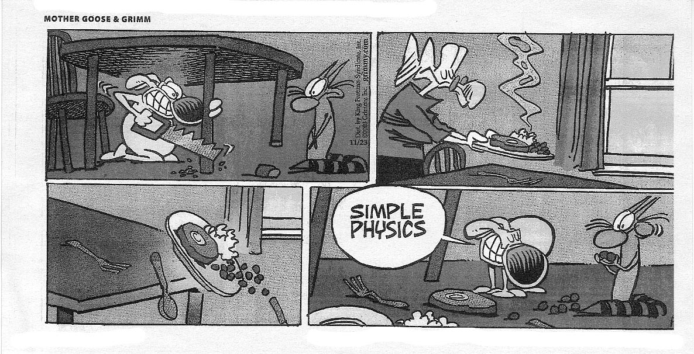
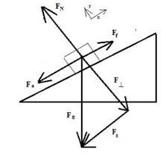

- A criminal wants to escape from the third story window of a jail by going down a rope to the road below. Having taken high school physics, he thinks he can escape down the rope even though his mass is 75 kg and the rope can only support 65 kg without breaking. Explain how he can get down safety without breaking the rope.

- A 7.6 kg object is at rest on an inclined plane. If the plane makes an angle with the horizontal of 33º what is the normal force acting on the object?

- A 7.6 kg object is pulled up an inclined plane. If the plane makes an angle with the horizontal of 33º and the coefficient of friction is 0.20, what is the force of friction?

- A 16.2 kg object slides down an inclined plane at a constant velocity. If the plane makes an angle of 25º, what is the normal force acting on the object?

- A 445 N box is sliding down a frictionless 25º inclined plane. Find the parallel component of the weight that causes the box to slide

- A 325 N box is sliding down a frictionless 30.0º inclined plane. What is its acceleration?

- A 435 N box is sliding down a 40.0º inclined plane. If the acceleration of the box is 0.250 m/s², what is the force of friction acting on the box?

- A student pulls a 125 N object up a 25º incline. If the coefficient of friction is 0.180, what force must the student pull with to move the object at a constant velocity? Assume the applied force is parallel to the ramp (why would that matter?)

Unit Connection! Mr. Lawson sure love’s these! Acceleration is the gatekeeper between the Kinematics and Dynamics Units.

Try the next two NON-Incline problem first:

- A 110 kg motorbike carrying 50.0 kg rider coasts to a stop in a distance of 51 m. It was originally traveling 15 m/s. What was the stopping force exerted by the road on the motorbike and rider? (HINT: start with kinematics)
- A truck of mass 2.00 x 10³ kg is towing a large mass boulder of mass 5.00 x 10² kg using a chain (of negligible mass). The tension in the chain is 3.00 x 10³ N. And the force of friction of the boulder is 1.20 x 10³ N.
  - At what rate will the boulder accelerate? (Hint: Start with Drynamics!)
  - How far will the boulder move in 3.0 s, starting from rest?

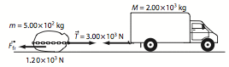

- Fluffy the cat slides freely down the long porcelain cat slide into the Beverly Hills pet pool. If the incline is 18° and μ = 0.10 determine the time it takes Fluffy to reach the bottom of the 10. m slide.
(HINT: find acceleration first, don’t worry about the cat’s mass, it cancels out)

- A trucker loses his brakes and hits the bottom of a runoff road (put there to protect against such a situation) at 150 km/h. The runoff road is inclined at 50° and friction against the truck is approximately equal to a sliding coefficient of 0.20. If the runoff road is 100 m long, is it long enough?

Worksheet 2.3 - Answers:

- If he presses his feet against the wall at an angle of 30º, he lowers the tension on the rope to a point where he safety lower himself an escape! Criminals are so badass (well not really…)
- (62 N)
- (12 N)
- (144 N)
- (188N)
- (4.90 m/s²)
- (269 N)
- (73.2 N)
- (-3.5 x 10² N)
- a. (3.60 m/s²) b. (16 m)
- (3.1 s)
- (just barely, by 1.0 m)

