Worksheet 2.1 -

A Worksheet
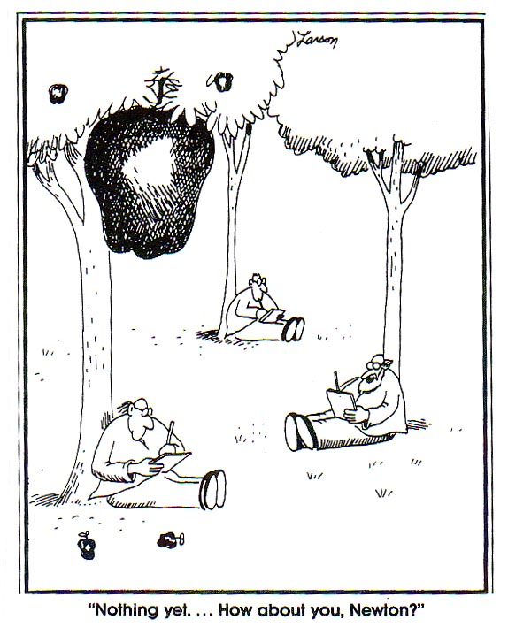
Show ALL WORK including knowns and steps taken to solve the problem!
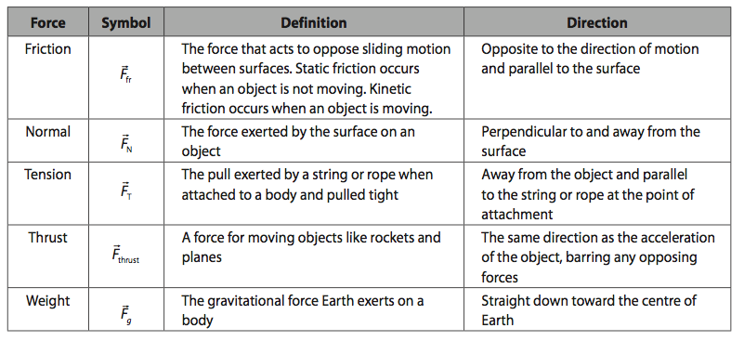

- How much force do the expanding gases in a gun barrel exert on a 6.0 g bullet as it accelerates from rest to 500.0 m/s in the 0.70 m long barrel?

- A 0.10 g spider is descending on a strand of web which supports it with a force of 5.6 x 10⁻⁴ N. What is the acceleration of the spider?

- A 75 kg criminal wants to escape from the 5th storey window of the jail, 24 m above the ground. He has a rope but it can only support a tension force of 650 N.
a. What is the minimum acceleration he can have as he lowers himself?
b. How fast is he traveling when he hits the ground below?

- If the force of friction between a 25 kg crate of expectations and the floor is 75 N, determine the force required to accelerate the crate at 1.5 m/s².

- A working boy pushes a 15 kg lawnmower at constant speed with a force of 90.0 N directed along the handle which is at an angle of 30° below the horizontal.
a) Calculate the friction force the boy is overcoming.
b) Calculate the normal reaction force on the mower from the ground.
BONUS) Calculate the coefficient of friction between the mower wheels and the ground.
BONUS 2) Calculate how hard the boy would have to push on the handle to give the mower an acceleration of 0.80 m/s².

- There you are standing on a train (off to Hogwart’s!) which begins to accelerate away from Platform 7 5/8 at 4.50 m/s². If you have a mass of 83 kg, what is the minimum force of friction required between your feet and the so that you do not slide backwards relative to the train?

- You are pushing a 3.75 kg textbook against a wall. What is the minimum force of friction between the book and the wall required so that it does not slip?

- A 1.20 x 10³ kg car is traveling at a speed of 22.5 m/s when the brakes are applied. If the car comes to a stop in 112 m, what is the braking force? (assume uniform deceleration)

- A hockey puck is shot along the ice at 11 m/s and slides 25 m before coming to a stop. What is the coefficient of friction?

- Two blocks (m₁ = 6.8 kg, m₂ = 5.2 kg) are in contact with each other while sitting on a frictionless surface as shown in the diagram. A horizontal force of 85 N is applied to m₁.
m₁
m₂

a. What is the acceleration of the system?
b. What is the force that m₁ exerts on m₂?

- A 42 N block is pulled along a horizontal surface by a force of 28 N as shown. What is the normal force on the block?
25º
42 N

- What is the tension in the cable of an 1.20 x 10³ kg elevator that is
a. accelerating downwards at 1.05 m/s²?
b. accelerating upwards at 1.05 m/s²?
c. moving down at a constant velocity?
1.0 kg
1.5 kg
- A 1.0kg box on a frictionless surface is attached to a 1.5 kg box as shown. What is the acceleration of the 1.0 kg box?

1.5
2.0

- Two masses are hung from a frictionless pulley as shown. What is the acceleration of:
a. the 1.5 kg block?
b. the 2.0 kg block?

- Two blocks are tied together as shown. IF a force of 20.0 N is applied to the 2.0 kg block:
3.0 kg
2.0 kg
T = 20.0 N

a. what is the acceleration of the blocks if the surface is frictionless?
b. What is the tension in the string joining the two blocks?
- Repeat question #15 when the coefficient of friction between the two blocks and the surface is 0.21.

Answers:
- (1.1 x 10³ N)
- (- 4.2 m/s² or 4.2 m/s² downward)
- a. (1.1 m/s²) b. (7.3 m/s)
- (110 N)
- a. (78 N) b. (1.9 x 10² N) BONUS (0.41) BONUS2 (1.1 x 10² N)
- (370 N)
- (37 N)
- (2.71 x 10³ N backwards)
- (0.25)
- a. (7.1 m/s²) b. (37 N)
- (30 N)
- a. (1.05 x 10⁴ N) b. (1.30 x 10⁴ N) c. (1.18 x 10⁴ N)
- (5.9 m/s²)
- a. (1.4 m/s² up) b. (1.4 m/s² down)
- a. (4.0 m/s²) b. (12 N)
- a. (1.9 m/s²) b. (12 N)

