Worksheet – Intro to Capacitance

- A 30 μF capacitor is connected to a 9.0 V battery.
  - Calculate the charge on the capacitor.
  - How many excess electrons are there on the negative plate of the capacitor? (Elementary charge e = 1.6 × 10^{–19} C)

- The potential difference across a capacitor is 3.0 V and the charge on the capacitor is 150 nC. Determine the charge on the capacitor when the potential difference is:
  - 6.0 V
  - 9.0 V.

- A 1000 μF capacitor is charged to a potential difference of 9.0 V.
  - Calculate the energy stored by the capacitor.
  - Determine the energy stored by the capacitor when the potential difference across it is doubled.

- You have three capacitors: 1.5 mF, 2.0 mF and 3.0 mF. What are the maximum and minimum equivalent capacitances you can obtain by combining these three capacitors? How did you combine the capacitors in order to obtain a minimum and maximum?

- For each circuit below, determine the total capacitance of the circuit.
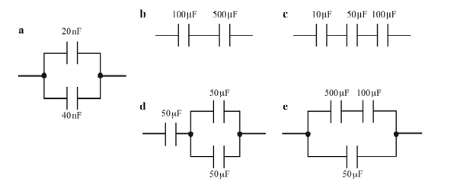
- The diagram shows an electrical circuit.
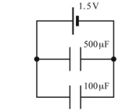
- Calculate the total capacitance of the two capacitors in parallel.
- What is the potential difference across each capacitor?
- Calculate the total charge stored by the circuit.
- Calculate the total energy stored by the capacitors.

Answers:

- a. 3.3 x 10⁻⁶ C b. 2.1 x 10¹³ electrons
- a. 30 μF b. 45 μF
- a. 0.041 J b. 0.16 J
- MAX = 6.5 mF – connect in parallel MIN = 0.67 mF connect in series
- a. 60 nF b. 83 μF c. 7.7 μF d. 33 μF e. 130 μF
- a. 600 μF b. 1.5 V c. 9.0 x 10⁻⁴ C d. 6.8 x 10⁻⁴ J

