Quiz 4c: Cycloalkanes

/5

Name the following Cycloalkanes:
- 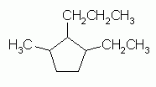
- 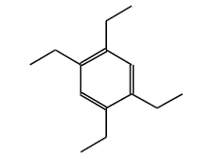
Draw the following Cycloalkanes:
- 1,2,3,4,5,6-hexamethylcyclohexane

- 1,1-diphenylheptane

Name the following Cycloalkanes:
Cyclooctane
1-ethyl-3-methyl-2-propylcyclopentane
OR
3-ethyl-1-methyl-2-propylcyclopentane
1,2,4,5-tetraethylbenzene
Draw the following Cycloalkanes:
- 1,2,3,4,5,6-hexamethylcyclohexane | 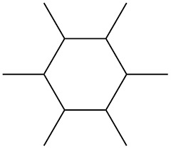
- 1,1-diphenylheptane | 