Quiz 4b: Cycloalkanes

/5

Name the following Cycloalkanes:
- 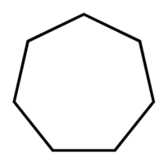
- 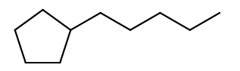
- 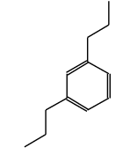
Draw the following Cycloalkanes:
- 1,1,2-trimethylcyclopentane

- 1-hexylbenzene

Name the following Cycloalkanes:
Cycloheptane
1-cyclopentylpentane
OR
1-pentylcyclopentane
1,3-dipropylbenzene

Draw the following Cycloalkanes:
- 1,1,2-trimethylcyclopentane | 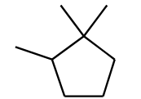
- 1-Hexylbenzene | 