Quiz 4a: Cycloalkanes

/5

Name the following Cycloalkanes:
- 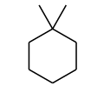
- 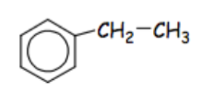
- 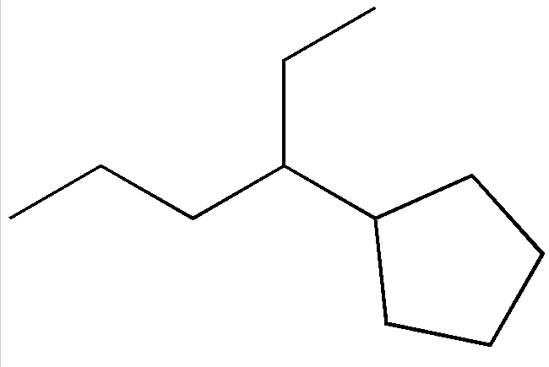
Draw the following Cycloalkanes:
- 1,2-dimethylcyclopropane
- 4-phenyl-2-hexene

Name the following Cycloalkanes:
1,1-dimethylcyclohexane

1-ethylbenzene
3-cyclopentylhexane

Draw the following Cycloalkanes:
- 1,1-dimethylcyclopropane | 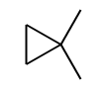
- 4-phenyl-2-hexene | 