Quiz 3c: Alkenes and Alkynes

/5

Name the following Alkenes and Alkynes:
- 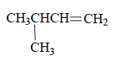
- 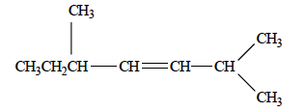
- 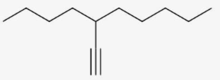
Draw the following Alkenes and Alkynes:
- 4-octene

- 3-ethyl-4-methyl-2-pentene

Name the following Alkenes and Alkynes:

3-methyl-1-butene

2,5-dimethyl-3-heptene
3-butyl-1-octyne
Draw the following Alkenes and Alkynes:
- 4-octene | 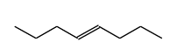
- 3-ethyl-4-methyl-2-pentene | 