Quiz 3b: Alkenes and Alkynes

/5

Name the following Alkenes and Alkynes:
- 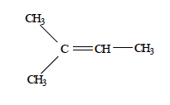
- 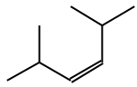
Draw the following Alkenes and Alkynes:
- 2,3-dimethyl-2-pentene
- 3,4-dimethyl-1-heptyne
What is wrong with the name of the following organic structure?
- 4-heptyne

Name the following Alkenes and Alkynes:
2-methyl-2-butene
2,5-dimethyl-3-hexene
Draw the following Alkenes and Alkynes:
- 2,3-dimethyl-2-pentene | 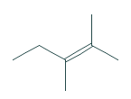
- 3,4-dimethyl-1-heptyne | 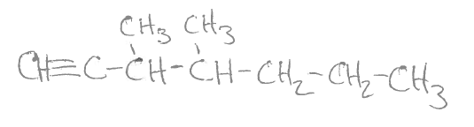
What is wrong with the name of the following organic structure?
- 4-heptyne | 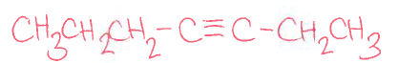
*Should be 3-heptyne!

