Quiz 3a: Alkenes and Alkynes

/5

Name the following Alkenes and Alkynes:
- 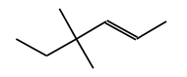
- 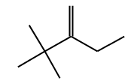
- 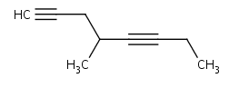

Draw the following Alkenes and Alkynes:
- 3-ethyl-2-methyl-2-pentene

- 5,6-dimethyl-2-octyne
Name the following Alkenes and Alkynes:
4,4-dimethyl-2-hexene

2-ethyl-3,3-dimethyl-1-butene

4-methyl-1,5-octadiyne

Draw the following Alkenes and Alkynes:
- 3-ethyl-2-methyl-2-pentene | 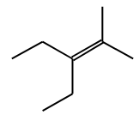
- 5,6-dimethyl-2-octyne | 