Quiz 1a: Straight Chain Alkanes

/5

Fill in the blanks of the following table:
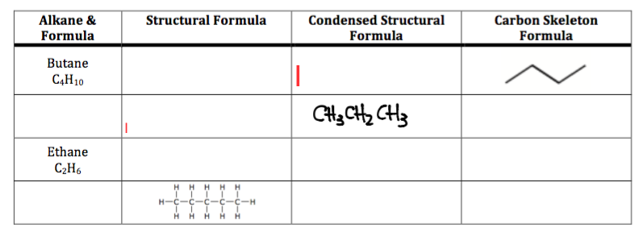

Answers: (1/2 mark for each right answer)

Fill in the blanks of the following table:
