Unit 4 – Thermo: Quiz 5c

/5

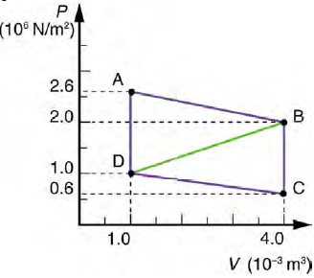
To the right is a PV diagram that shows multiple step thermodynamic cycle that follows the path ABCDA.

- What is the name of the thermal dynamic process as the gas goes from point “B” to point “C”?

- Calculate the net work output of a heat engine following the path ABCDA.

- Calculate the net work output of a heat engine that follows path ABDA, with a straight line from B to D.

Answers:

- Isobaric

- 4500 J by the gas

- 2400 J by the gas

