**Unit 4 – Thermo: Quiz 4a**

/5

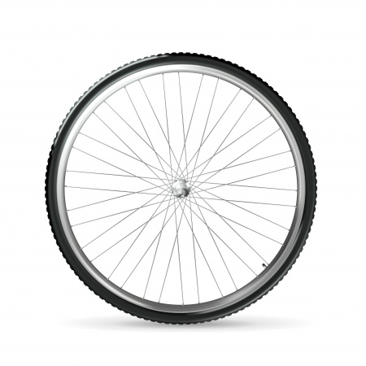

1. Suppose your bicycle tire is fully inflated, with an absolute pressure of 7.00×105 Pa (a gauge pressure of just under 90.0 lb/in2) at a temperature of 18.0 oC. What is the pressure after its temperature has risen to 35.0 oC? Assume that there are no appreciable leaks or changes in volume.

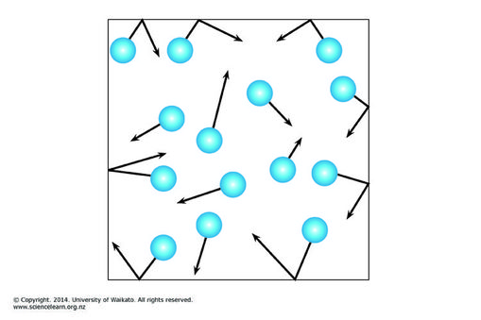

1. What is the average kinetic energy per molecule of a tank of oxygen gas at 28.0 °C?
2. What is the average velocity of the particles of xenon at 255 K?

Answers:

1. Suppose your bicycle tire is fully inflated, with an absolute pressure of 7.00×105 Pa (a gauge pressure of just under 90.0 lb/in2) at a temperature of 18.0 oC. What is the pressure after its temperature has risen to 35.0 oC? Assume that there are no appreciable leaks or changes in volume.



1. What is the average kinetic energy per molecule of a tank of oxygen gas at 28.0 °C?

  







1. 

First we need mass of a xenon molecule.



