The Goldilocks Principle: One two hot, one two cold and one just right…
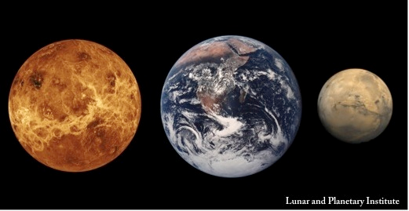
Figure 1: Venus, Earth and Mars
Of the nine planets in our solar system, the closest to Earth are Mars (about 50-percent farther from the Sun) and Venus (about 30-percent closer). Venus' surface temperature is about 900 degrees Fahrenheit (482 degrees Celsius), whereas a warm day on Mars is like one of the cooler days in Antarctica. What happened to these planets to make them so inhospitable for biological organisms as we know them?
Carbon dioxide is a greenhouse gas, which means it traps warmth in the form of infrared radiation like a gaseous "blanket" over a planet's atmosphere. Earth's oceans contain about 60 times more carbon dioxide than its atmosphere. In fact, carbon dioxide gas makes up very little (less than 1 percent) of the Earth's atmosphere. The rest is made up of about three-fourths nitrogen, one-fourth oxygen, some argon, carbon dioxide and other trace gases.
However, the small amount of carbon dioxide is essential for keeping Earth warm. It works with the water vapor in the atmosphere to keep Earth's oceans from freezing. By dissolving carbon dioxide and re-releasing it into the atmosphere, the oceans can be thought of as controlling the temperature of our planet (this process is, of course, much more complex).
If all the carbon dioxide in our oceans were released at once, our atmosphere would become unbearably hot. The same effect would take place if humans released too much carbon dioxide into the atmosphere by polluting processes such as the internal combustion engine. (Pollution has increased the amount of carbon dioxide in our atmosphere by at least 25 percent in the last 150 years.)
Some scientists believe that Venus had an ocean. According to the theory, Venus was too close to the Sun to maintain it. When water vapor reached the upper atmosphere, the ultraviolet light from the Sun would break it into its components -- oxygen and hydrogen -- the latter of which escaped into space. As Venus' oceans were evaporating, their carbon dioxide was released into the atmosphere, which caused increasing heat, which, in turn, caused increasing evaporation, and so on. This is called the " runaway greenhouse effect " and is the reason why Venus is so hot today.
Mars, on the other hand, may have been just right for habitability during the early days of the solar system. It likely had a great ocean, lakes and thermal vents. But unlike Earth, Mars does not have plate tectonics -- the recycling of the continents that are so active on Earth. The movement of the continents folds the rocks deep into Earth's crust, re-melting and vaporizing them, thus re-releasing the oxygen and other atmospheric constituents they contain back into our atmosphere.
So what happened on Mars? Mars is about one-tenth the size (mass) of Earth and therefore cooled much faster (as smaller things do). If Mars had much plate tectonic activity it has long since stopped, as the interior of Mars cooled more rapidly than Earth's did. Mars was not able to recycle its rocks and so its atmosphere is mostly "trapped" within them today. Without much of an atmosphere to keep it warm, Mars remains a very cold place -- too cold , and with too sparse an atmosphere , to allow liquid water to persist on its surface.
Thus we have two very interesting examples of how our neighborhood planets work. Mars lets us appreciate our planet's continual recycling. Venus, on the other hand, warns us to avoid carbon dioxide pollution if we want to keep our planet at the nice, cool liquid water temperature it now has. What would have happened if Venus had been located in Mars' orbit? If this was the case, we might have had two habitable, liquid-water planets in our solar system today.

