Study Guide: MATTER UNIT TEST

Are you Beginning, Developing, or Accomplished at each of the following learning goals? Go through the check list and mark each row as “B”, “D”, or “A” based on your level of understanding. Use the “B”s as areas to focus on when you’re studying!
KNOW
B | D | A | LEARNING GOAL
 |  |  | The relationship between atomic number, protons and electrons for a neutral atom
 |  |  | How to define matter, mass, and volume
 |  |  | How to list ist the 4 points of the Kinetic Molecular Theory
For the three states of matter, I can state:
- If shape is fixed or if it takes the shape of its container
- If volume is fixed or if it takes the volume of its container
- how particles move
- how particles are spaced
- how strong attractive forces between particles are
- what the relative energy level is (compared to the other states of matter)
 |  |  | I can describe how to measure mass and volume of liquids and regularly- and irregularly-shaped solids
 |  |  | I can define density and describe how it changes with temperature

DO
B | D | A | LEARNING GOAL
 |  |  | Can Identify the mass number, atomic number, # of protons/neutrons/electrons for an element
 |  |  | Draw (Bohr) Diagrams to represent the placement of electrons around the nucleus
I can describe changes of state in matter in terms of the Kinetic Molecular Theory**
(vocab: melting, evaporation, sublimation, condensation, deposition, solidification)
 |  |  | I can calculate density, mass, or volume if given the two other values
 |  |  | I can predict how substances will layer based on their density
 |  |  | I can describe how temperate affects density and buoyancy in terms of the Kinetic Molecular Theory**

**“In terms of the Kinetic Molecular Theory” means that you can describe what is happening to the particles (movement, spacing, attraction, energy)

KMT and Density Review Package:
Kinetic molecular theory explains the characteristics of solids, liquids, and gases.

- The particle model of matter describes how particles of solids are closer together than particles of liquids. Particles of a gas are spread far apart.
- Kinetic molecular theory describes how adding energy to particles makes them move faster and farther apart.
- Adding or removing energy from matter can cause changes in the state of matter.
- Liquids and gases are fluids, forms of matter that can flow.
- Density is a way to describe how closely particles are packed together in a solid, liquid, or gas.
- Density is calculated by dividing mass by volume.
Atoms, KMT and Density
- atom
- element
- compound
- proton’s/electron’s/neutrons
- Atomic Number
- Mass Number
- condensation
- density
- displacement
- evaporation
- expansion
- fluid
- mass
- melting
- solidification
- sublimation
- volume
What to Do
Read the points listed below, which make up the kinetic molecular theory. Use them to help you explain the statements that follow.
The Kinetic Molecular Theory
- All matter is made up of very small particles.
- There is empty space between particles.
- Particles are constantly moving.
- Energy makes particles move.

Section 1
- What is the atomic mass of Carbon: _____
- What is the atomic symbol for Sodium: _____
- What is the number of neutrons in Lithium: _____
- What is the number of electrons in Neon: _____
- What is the number of protons in Boron: ______
- What is the atomic mass of Helium: ______
- What subatomic particle is positively charged: ___________
- What subatomic particle is negatively charged: ____________
- What subatomic particle is neutral in charge: ____________
- What two particles are in the nucleus: ______________
- The atomic number of an atom is determined by the number of ____________________.
- The mass number of an atom is determined by the number of ____________ and _____________
- Which two subatomic particles have an equal, but opposite charge? ___________________________.
- If an ion has a negative charge, it contains (more, less) electrons than protons.
- If an ion has a positive charge, it contains (more, less) electrons than protons.
Fill in the blanks.
17. Platinum (Pt) 18. Tungsten (W) 19. Iodine (I)
Protons: 78 Protons: ________ Protons: 53
Neutrons: 117 Neutrons: 110 Neutrons: ________
Electrons: ________ Electrons: ________ Electrons: ________
Atomic Number: ________ Atomic Number: ________ Atomic Number: ________
Mass Number: ________ Mass Number: 184 Mass Number: 127

20. Zirconium⁺² (Zr⁺²) 21. Phosphorus⁻³ (P⁻³) 22. Osmium
Protons: ________ Protons: _______ Protons: _____
Neutrons: ________ Neutrons: 16 Neutrons: _____
Electrons: ________ Electrons: 18 Electrons: _____
Atomic Number: 40 Atomic Number: ______ Atomic Number: 76
Mass Number: 91 Mass Number: ______ Mass Number: 190
For each element:
For each element, write the total number of electrons on the line. Then color the correct number of electrons for each orbit. Remember, fill the orbit closest to the nucleus first, but never exceed the number each orbit can hold. Check the Periodic Table to find out how many electrons each element actually has.
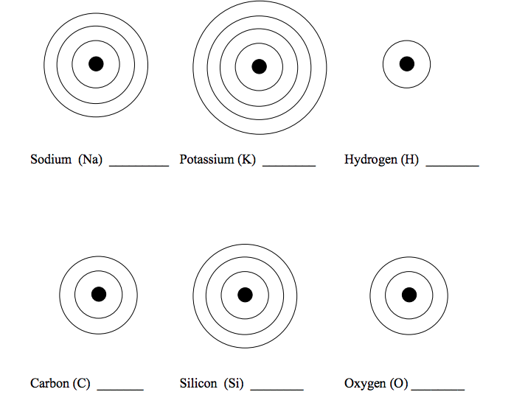
Section 2
Statements
1. Solids have a definite shape because

__________________________________________________________________________________________

2. Liquids and gases flow because

__________________________________________________________________________________________
3. Ice cubes form in the freezer because

__________________________________________________________________________________________
4. Ice cream melts quickly on a hot day because

__________________________________________________________________________________________
5. Gases do not have a definite shape because

__________________________________________________________________________________________

Match each description with the correct change of state. Write the letter for the change of state in the space at the end of the descriptions. You may use some changes of state more than once.

Descriptions | Changes of State
1. Ice is left out on the counter. ___________________ | (a) sublimation
2. Frost forms on the window on a cold day. ___________________ | (b) condensation
3. Water is left in a freezer. ___________________ | (c) evaporation
4. Clothes are left out to dry. ___________________ | (d) deposition
5. Dry ice is used to create fog. ___________________ | (e) melting
6. The bathroom mirror gets fogged up after a shower. ___________ | (f) solidification

7. A pond gets shallower at the end of a long hot summer. _________

8. Your hair was wet when you left the house, but dries by the time you get to school. ___________________
9. The ice cream you are eating drips down your arm. _______________

10. A full pot of soup fills only half of the pot after simmering
for 2 h. ___________________

11. Liquid glass cools and hardens. ___________________

12. A cold drink is wet on the outside of the glass. _________________
Section 3: Answer these questions making sure to create a list of knowns/unknowns, show a conceptual equation and include a statement with your answer.
1. A student measures the mass of an 8 cm³ block of brown sugar to be 12.9 g. What is the density of the brown sugar?
2. A chef fills a 50 mL container with 43.5 g of cooking oil. What is the density of the oil?
3. A machine shop worker records the mass of an aluminum cube as 176 g. If one side of the cube measures 4 cm, what is the density of the aluminum?
4. Based on the density values see below, list how the following liquids would layer in a beaker from top to bottom: glycerol, ethyl alcohol, mercury, seawater, machine oil, water.
Fluid | Density (g/mL) | Solid | Density (g/cm³)
hydrogen | 0.000 09 | StyrofoamTM | 0.005
helium | 0.0002 | cork | 0.24
air | 0.0013 | oak | 0.70
oxygen | 0.0014 | sugar | 1.59
carbon dioxide | 0.002 | salt | 2.16
ethyl alcohol | 0.79 | aluminum | 2.70
machine oil | 0.90 | iron | 7.87
water | 1.00 | nickel | 8.90
seawater | 1.03 | copper | 8.92
glycerol | 1.26 | lead | 11.34
mercury | 13.55 | gold | 19.32
5. A teacher performing a demonstration finds that a piece of cork displaces 23.5 mL of water. The piece of cork has a mass of 5.7 g. What is the density of the cork?
6. A carver begins work on a block of granite that measures 20 cm by 10 cm by 5 cm. If the block of granite has a mass of 2700 g, what is the density of the granite?
7. A piece of PVC plumbing pipe displaces 60 mL when placed into a container of water. If the pipe has a mass of 78 g, what is the density of PVC?
8. A solid magnesium flare has a mass of 1300 g and a volume of 743 cm³. What is the density of the magnesium?
9. An ice cube has a volume of 12 cm-, and a mass of 11 g. What is the density of the ice?
10. Gold is one of the densest substances on Earth. A gold bar 20 cm by 5 cm by 5 cm has a mass of 9.7 kg. What is the density of gold? Express your answer in g/cm³.
Section 4:
Use the table to solve the following problems.
Fluid | Density (g/mL) | Solid | Density (g/cm³)
hydrogen | 0.000 09 | StyrofoamTM | 0.005
helium | 0.0002 | cork | 0.24
air | 0.0013 | oak | 0.70
oxygen | 0.0014 | sugar | 1.59
carbon dioxide | 0.002 | salt | 2.16
ethyl alcohol | 0.79 | aluminum | 2.70
machine oil | 0.90 | iron | 7.87
water | 1.00 | nickel | 8.90
seawater | 1.03 | copper | 8.92
glycerol | 1.26 | lead | 11.34
mercury | 13.55 | gold | 19.32

1. Calculate the mass of 550 mL of air.

2. Calculate the mass of 50 cm³ of copper.

3. What is the volume of a 2 g piece of gold?

4. How much space would 1 kg of air occupy?

5. In an experiment, two students find that 500 g of water occupies a space of 50 mL. Is this accurate? Explain.

6. In the same class, two students find that a piece of wood with a mass of 70 g has a volume of 103 cm³. They conclude that the wood is oak. Is this accurate? Explain.

Section 5:
Use the information in the table to answer the following questions.

Fluid | Density (g/mL) | Solid | Density (g/cm³)
hydrogen | 0.000 09 | StyrofoamTM | 0.005
helium | 0.0002 | cork | 0.24
air | 0.0013 | oak | 0.70
oxygen | 0.0014 | sugar | 1.59
carbon dioxide | 0.002 | salt | 2.16
ethyl alcohol | 0.79 | aluminum | 2.70
machine oil | 0.90 | iron | 7.87
water | 1.00 | nickel | 8.90
seawater | 1.03 | copper | 8.92
glycerol | 1.26 | lead | 11.34
mercury | 13.55 | gold | 19.32

1. You drop three things into a glass of water: a piece of StyrofoamTM, a piece of oak, and a gold ring.
(a) Which will float?
(b) Which will sink?

2. Which is denser:
(a) carbon dioxide or air?
(b) oxygen or air?
(c) hydrogen or air?

3. You find a white granular substance in a jar in your cupboard. You suspect that it may be either sugar or salt. How could you find out without tasting the substance?

4. Why is it easier to swim in seawater than it is to swim in fresh water?

5. A student comes to the conclusion that solids are denser than liquids. Is this true? Explain.

Answers:
Section1: Atomic Theory
- 12.01g
- Na
- 4
- 10
- 5
- 4.00g
- proton
- electron
- neutron
- neutron + proton
- protons
- proton, neutrons
- proton, electrons
- MORE
- LESS
17. Platinum (Pt) 18. Tungsten (W) 19. Iodine (I)
Protons: 78 Protons: 74 Protons: 53
Neutrons: 117 Neutrons: 110 Neutrons: 74
Electrons: 78 Electrons: 74 Electrons: 53
Atomic Number: 78 Atomic Number: 74 Atomic Number: 53
Mass Number: 195 Mass Number: 184 Mass Number: 127
20. Zirconium⁺² (Zr⁺²) 21. Phosphorus⁻³ (P⁻³) 22. Osmium (Os)
Protons: 40 Protons: 15 Protons: 76
Neutrons: 51 Neutrons: 16 Neutrons: 114
Electrons: 38 Electrons: 18 Electrons: 76
Atomic Number: 40 Atomic Number: 15 Atomic Number: 76
Mass Number: 91 Mass Number: 31 Mass Number: 190
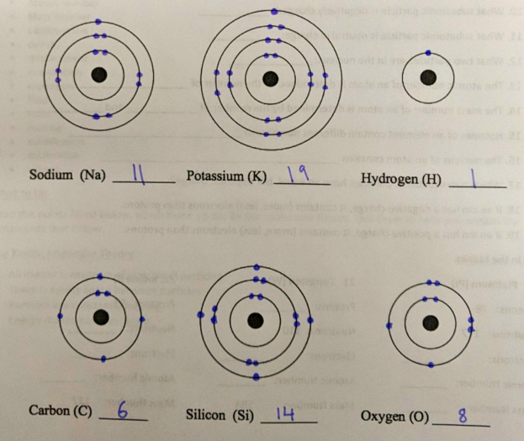
Section2a: The Kinetic Molecular Theory
- Solids have a definite shape because the particles are so close together that they cannot move around freely; they can only vibrate.
- Liquids and gases flow because their particles are farther apart than those of a solid and therefore can move more freely.
- Ice cubes form in the freezer because the water particles lose energy and slow down when the temperature decreases.
- Ice cream melts quickly on a hot day because the particles gain energy as the temperature increases.

Section 2b: Identifying Changes of State
- (e) melting
- (d) deposition
- (f) solidification
- (c) evaporation
- (a) sublimation
- (b) condensation
- (c) evaporation
- (c) evaporation
- (e) melting
- (c) evaporation
- (f) solidification
- (b) condensation

Section 3: Calculating Density Practice Problems
- 1.61 g/cm³
- 0.87 g/mL
- 2.75 g/cm³
- ethyl alcohol, machine oil, water, seawater, glycerol, mercury
- 0.24 g/mL
- 2.7 g/cm³
- 1.3 g/cm³
- 1.75 g/cm³
- 0.917 g/cm³
- 19.4 g/cm³

Section 4: Density Calculations
- 0.715 g
- 446 g
- 1 cm³
- 769 230 mL
- No. This is not accurate. The students must have made a mistake with a decimal place. This combination of mass and volume would not be the proper density.
- This may be correct. The density of oak is 0.70 g/cm³, which is very close to the students’ results

Section 5: Comparing Densities
- The StyrofoamTM and oak would float. The gold ring would sink.
- 2. (a) Carbon dioxide is denser than air.
- (b) Oxygen is denser than air.
- (c) Air is denser than hydrogen.
- Salt is denser than sugar. You may be able to determine the identity of the substance by comparing the mass-to-volume ratios to that of sugar or salt.
- Seawater is denser than fresh water. Therefore, it seems easier to float in the sea. However, some students may bring up the issue of waves and currents, which make it difficult to swim in seawater.
- Generally, most solids seem to be denser than most liquids, but there are many exceptions. StyrofoamTM and cork are not dense, but they are solids. Mercury is a liquid, but it is quite dense. Thus, the statement is not always true.

