**Unit 6: Quiz 6c**

/5

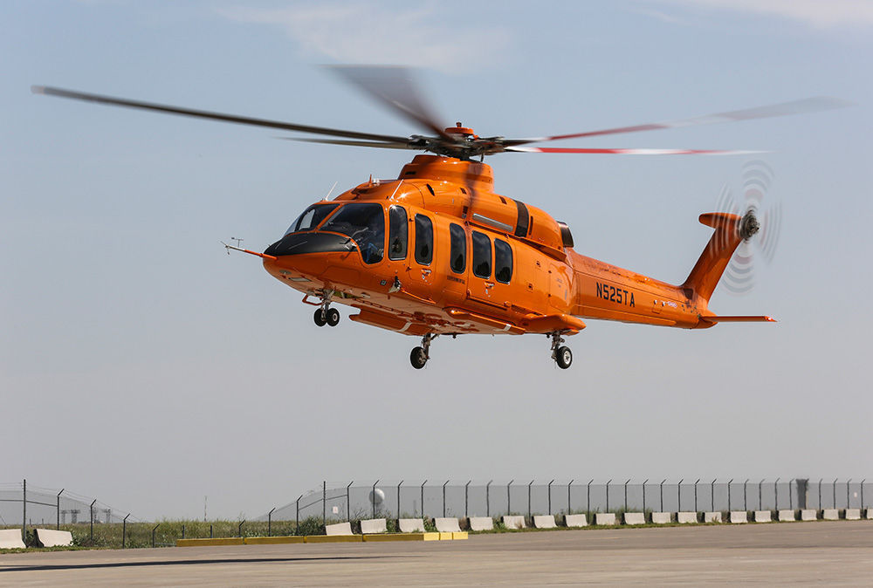

After exiting a helicopter, you notice that the rotor's motion changed from 300. rpm to 225 rpm in 1.00 minutes. Each blade of the rotor is 2.95 meters in length.

1. Find the magnitude of the angular acceleration ***(in rad/s2)*** of the rotor.
2. Find the magnitude of the linear acceleration **(in m/s2)** of the tip of the rotor.
3. Calculate the angular distance ***(in rads)*** through which the rotor moved during the 1.00-minute time interval.

After exiting a helicopter, you notice that the rotor's motion changed from 300. rpm to 225 rpm in 1.00 minutes. Each blade of the rotor is 2.95 meters in length.

1. Find the magnitude of the angular acceleration ***(in rad/s2)*** of the rotor.



1. Find the magnitude of the linear acceleration **(in m/s2)** of the tip of the rotor.



1. Calculate the angular distance ***(in rads)*** through which the rotor moved during the 1.00-minute time interval.



