Module 5 – Nuclear and Atomic Physics: Quiz 4b

- Light exhibits a wave-particle duality. An apple does not exhibit wave like properties because…. (EXPLAIN your reasoning)
- apples have a large mass
- apples are made of particles
- apples do not travel at speeds close to the speed of light
- on Earth, gravity acts on particles like apples, but not waves
- the laws of quantum mechanics can only be applied to subatomic particles

- Give two examples (one for particles one for waves) of how light can act as both a wave and a particle.

Answers:

- Light exhibits a wave-particle duality. An apple does not exhibit wave like properties because….
- apples have a large mass
- apples are made of particles
- apples do not travel at speeds close to the speed of light
- on Earth, gravity acts on particles like apples, but not waves
- the laws of quantum mechanics can only be applied to subatomic particles

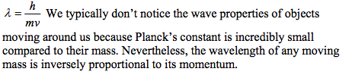

- Particle: Scattering, Photoelectric Effect Wave: Diffraction, Interference

