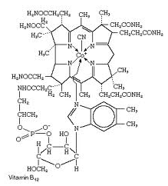 | Organic Chemistry | Name:  Date:
Lewis Structure for Carbon:

A carbon atom has _____ valence electrons.

Organic Compounds
- Contain carbon atoms usually bonded to other carbon atoms and hydrogen atoms.

  - Called _________________________________

- Organic compounds may also contain: ____________________________________________________________

Examples of organic compounds:
- Scientists thought that organic compounds contained a “life force” or “vitality.
- Was proved incorrect in 1828 when an inorganic salt was heated to produce an organic compound.

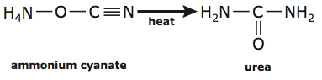

Inorganic Carbon Compounds
- Even if a compound contains carbon, it may not be classified as an organic compound.

Simple Hydrocarbons

- Recall that a carbon has _____ valence electrons.
- Each carbon atom can form _____ covalent bonds.
- With so many different ways that a carbon can bond…
  - There are ________________________of known organic compounds

  - There is an almost _________________________________ of unknown organic compounds

Alkanes

- Hydrocarbons containing only _____________________________.
- They are saturated – there is no room for other atoms to bond to the ______________________________.
- Chemical Formula:
# of C Atoms | Prefix | Alkane
1
2
3
4
5
6
7
8
9
10

Problem Set:
- Write out the condensed structural formula for all 10 straight-chain alkanes.

- Draw the carbon skeleton formula for all 10 straight-chain alkanes. (You cannot draw methane.)

- Draw a structural formula, condensed structural formula, and carbon skeletal formula for C₆H₁₄.

- Octane, a constituent of gasoline, has the molecular formula C₈H₁₈. Draw a structural formula, condensed structural formula and carbon skeleton formula for octane. Assume that the carbons are all bonded in a single chain to each other.

- What would the formula be for a straight chain alkane that had the following number of carbon or hydrogen atoms?
- 6 carbon atoms  - 12 carbon atoms  - 14 carbon atoms  - 29 carbon atoms  - 98 carbon atoms | - 102 hydrogen atoms  - 54 hydrogen atoms  - 84 hydrogen atoms  - 16 hydrogen atoms  - 4 hydrogen atoms

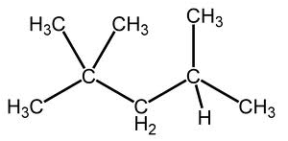 | Naming  Simple  Hydrocarbons | Name:  Date:
Steps to Naming Simple Alkanes:

- Find the ______________________________________________ of carbon atoms. It does NOT have to be in a straight line. This is called the _________________ chain.
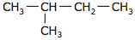 | The longest continuous chain of carbon atoms contains _____ carbon atoms
State the number of catbon atoms using the appropriate prefix and the ending “ane.”

The appropriate prefix would be _____________ and with the ending “ane” would be ______________________.

- Branches are called __________________ groups. Number the carbon atoms in the parent chain starting at the _________________________________________________.

- Name each branch.

Give a prefix according to the number of carbon atoms it contains. Branch names end in _____ instead of ___________.
List the branches in ______________________________. If more than one branch has the same number of carbon atoms use the prefixes ____________________________________________.

- Name each branch.

State the name of the alkane by naming each branch, then naming the parent. Use commas between numbers and hyphens between numbers and branches.

Practice #1.
- Parent Chain.  - Number the parent chain.  - Name the branches.  - Name the compound | 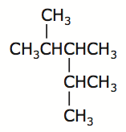
Practice #2.
- Parent Chain.  - Number the parent chain.  - Name the branches.  - Name the compound | 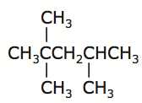
Practice #3.
- Parent Chain.  - Number the parent chain.  - Name the branches.  - Name the compound | 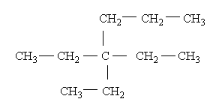

Practice #4.
- Parent Chain.  - Number the parent chain.  - Name the branches.  - Name the compound |  | 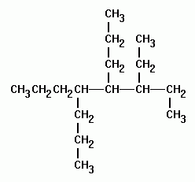
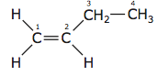 | Alkenes and Alkynes |  | Name:  Date:
Alkenes

- Hydrocarbons containing __________________ bonds.
- General Formula: _______________________
- They are unsaturated – the double bond is a _________________________ for other atoms to bond to the carbon atom.
# of C Atoms | Prefix | Alkene
2
3
4
5
6
7
8
9
10

Steps to Naming Alkenes:

- The ____________________________ must contain the double bond. (even if it is not the longest chain)

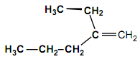 | The longest continuous chain of carbon atoms including the double bond contains _____ carbon atoms

- The parent chain carbon atoms are numbered….._____________________________________________________________________________________________

The double bond follows carbon #_______.

The parent chain is called ______________________.

- The position of the double bond is indicated in the name by stating the __________________________ of the carbon atom in the parent chain that the double bond follows.

Name the branches!

- Name the compound.

Practice #1.
- Parent Chain.

- Number the parent chain.

- Name the branches.

- Name the compound

Practice #2.
- Parent Chain.

- Number the parent chain.

- Name the branches.

- Name the compound

Alkynes

- Hydrocarbons containing ______________________ bonds.
- General Formula: _____________________________
- They are unsaturated – the double bond is a reactive site for other atoms to bond to the carbon atom.
Steps to Naming Alkynes:
- The same rules for naming an alkene apply; however the ending is “___________” instead of “____________.”
# of C Atoms | Prefix | Alkyne
2
3
4
5
6
7
8
9
10
Practice #1.
- Parent Chain.  - Number the parent chain.  - Name the branches.  - Name the compound | 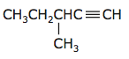
Practice #2.
- Parent Chain.  - Number the parent chain.  - Name the branches.  - Name the compound | 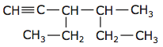

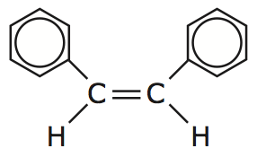 | Cyclic Structures | Name:  Date:
- Carbon atoms may bond to each other and form a ________________________________
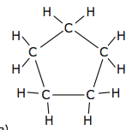 | Becomes… | 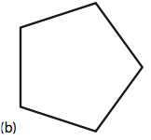

Steps to Naming Cyclic Structures:

- The ring that contains the greater number of carbon atoms is the _______________________________
- The prefix “_________________________” is placed before the parent chain name.
- Parent Chain = _______________________________

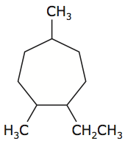

- The carbon atoms are numbered either clockwise or ________________________________________________.
- The ______________________________________ are used to identify the placement of the branches.

- Name the branches.

- Name the compound.

If the ring structure is not the longest continuous carbon chain, then it is named as a branch with prefix “cyclo” and ends in “yl.”
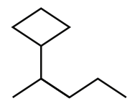
Parent: __________________________________

Branch: __________________________________

Compound:______________________________

Practice #1
- Parent Chain.  - Number the parent chain.  - Name the branches.  - Name the compound | 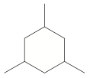
Practice #2
- Parent Chain.  - Number the parent chain.  - Name the branches.  - Name the compound | 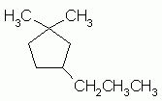

Practice #3
- Parent Chain  - Number the parent chain.  - Name the branches.  - Name the compound | 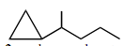

Aromatic Hydrocarbons

- Benzene is a hydrocarbon with _______________________________ atoms in a ring.
- It has the molecular formula _______________________________
- There is _____________________ than one way of drawing its Lewis structure.
- Equivalent Lewis structures are called _________________________ structures.
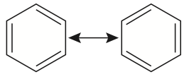
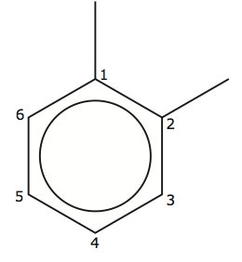Name: ________________________________

- Some organic compounds have benzene as a branch. In this case, the branch name is “_______________________________”
Practice #4
- Parent Chain.  - Number the parent chain.  - Name the branches.  - Name the compound | 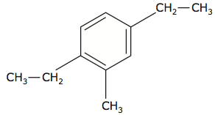
Practice #5
- Parent Chain.  - Number the parent chain.  - Name the branches.  - Name the compound | 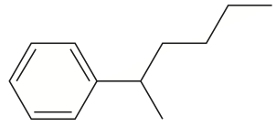

Practice #6
- Parent Chain.

- Number the parent chain.

- Name the branches.

- Name the compound

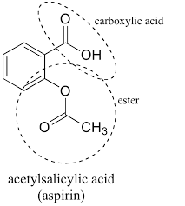 | Functional Groups | Name:  Date:
Isomers
Draw the structure for C₅H₁₂

- Structures that have the same ______________________________ but different chemical properties
- As the number of _________________________ increases, the number of ______________________________________________ increases.
- Pentane and 2-methylbutane are structural isomers. There is one more structural isomer. Can you find it?
Functional Groups

- An atom, group of atoms or type of bond in an organic molecule that react in a predictable manner.
- Symbol “R” is used to represent the ___________________________________________________ of the organic molecule.
Alkyl Halide

- X = ____________________________________
- Organic compounds containing _______________________________ are called alkyl halides
- The prefixes are:
- F= ____________________ Cl = ____________________ Br = ____________________ I = ____________________

Practice #1.
- Parent Chain.  - Number the parent chain.  - Name the branches.  - Name the compound | 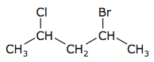

Practice #2.
- Parent Chain.  - Number the parent chain.  - Name the branches.  - Name the compound | 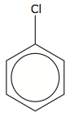

Alcohols: R-Oh

Naming alcohols:

  - The parent chain must contain the atom attached to the –OH group. Number the carbon atoms in the parent chain so that the –OH group is given the lowest number.
  - The name of the parent chain ends with “-ol” instead of “-e”.
  - Name and identify positions of the branches.
  - Name the compound.

Practice #1.
- Parent Chain.

- Number the parent chain.

- Name the branches.

- Name the compound

Practice #2.
- Parent Chain.  - Number the parent chain.  - Name the branches.  - Name the compound | 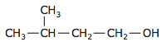

Practice #3.
- Parent Chain.  - Number the parent chain.  - Name the branches.  - Name the compound | 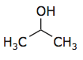

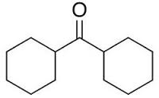 | Functional Groups II |  | Name:  Date:
Cis - Trans Isomerism
Draw the structure for 2-butene |  | Is there any other way to show this structure?
The double bond “____________________” the molecule in place and changes the _______________________ of the compound.
Naming Cis-Trans Alkene’s:
  - The parent chain must contain the ______________________________.
  - The name of the parent chain ends with “_________” instead of “____________”.
  - Determine if the molecule is “cis” (__________________) or “trans” (________________) AT the double bond and include it at the front of the parent chain
  - Include the ______________________ where the double bond starts before the parent chain
And as always…
  - Name and identify positions of the branches.
  - Name the compound.
Practice #1.
- Parent Chain.  - Number the parent chain.  - Name the branches.  - Name the compound | 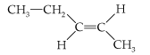

Practice #2.
- Parent Chain.  - Number the parent chain.  - Name the branches.  - Name the compound. | 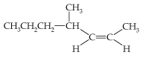

Aldehydes

Naming aldehydes:

- Organic compounds containing an oxygen at the ________________________ of a parent chain double bonded to a carbon.
- To name aldehydes remove the “____________” from the end of the parent chain and replace it with “______________”
Practice #3.
- Parent Chain.  - Number the parent chain.  - Name the branches.  - Name the compound | 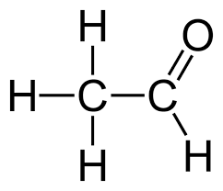

Practice #4.
- Parent Chain.  - Number the parent chain.  - Name the branches.  - Name the compound | 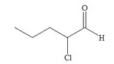

Ketones

Naming Ketones:

- Organic compounds containing an oxygen in the _____________________of a parent chain double bonded to a carbon.
- To name ketones remove the “____________” from the end of the parent chain and replace it with “____________________________________”

Practice #5.
- Parent Chain.  - Number the parent chain.  - Name the branches.  - Name the compound | 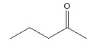

Practice #6.
- Parent Chain.  - Number the parent chain.  - Name the branches.  - Name the compound | 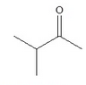

Ethers  Naming Ethers:  - Recognise that the molecule is an ether because it has the general form:  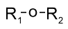  - Identify the _________________ labelled "R₁" and "R₂". Standard system of labelling carbon chains as used for alkanes.  - The shorter of the two chains "R₁" and "R₂" becomes the _________________________of the name with the “______________" suffix, and the name of the longer alkane chain forming the suffix of the name of the ether.  Practice #8.  - Parent Chain.  - Number the parent chain.  - Name the branches.  - Name the compound  Practice #9.  - Parent Chain.  - Number the parent chain.  - Name the branches.  - Name the compound | 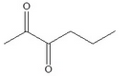

Practice #10.
- Parent Chain.

- Number the parent chain.

- Name the branches.

- Name the compound

Esters
Naming Esters:

- First, identify the ___________________ that is part of the continuous chain and bonded to carbon on both sides. (On one side of this ______________________ there will be a carbonyl present but on the other side there won't be.)
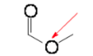
- Second, begin numbering the ___________________________ on either side of the _________________________ identified in step 1.
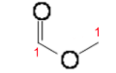
- Next, use this format: [alkyl on side ____________________ from the carbonyl] (space) [alkane on the ________________ with the carbonyl] - (In this case: [methyl] [methane])

- Finally, change the ending of the alkane on the same side as the carbonyl from ___________________________________.
(In this case: methyl methanoate)

Practice #11.
- Parent Chain.

- Number the parent chain.

- Name the branches.

- Name the compound

Practice #12.
- Parent Chain.

- Number the parent chain.

- Name the branches.

- Name the compound

Practice #13.
- Parent Chain.  - Number the parent chain.  - Name the branches.  - Name the compound | 