What is the length of this rectangle if the units of the ruler are cm?
The measurement using the ruler is between and cm. There is some doubt in the measurement. All measurements have a certain level of uncertainty.
The uncertainty of the measurement depends on the experimenter and the instrument making the measurement. (Why?)
A. Accuracy and Precision
- A precise measurement is a measurement that can be reproduced and, in general, has more significant digits (relevant digits).
e.g. a measurement of 2.53 cm is more precise than the measurement of 2.5 cm
- An accurate measurement is a measurement that is close to the correct value or accepted value. The accuracy depends on how the instrument is calibrated.
e.g. if the "right" length of a box is 2.45 m, then a measurement of 2.41 m is more accurate than a measurement of 2.33345 m. Note that the latter measurement is more precise than the first measurement, but not as accurate.
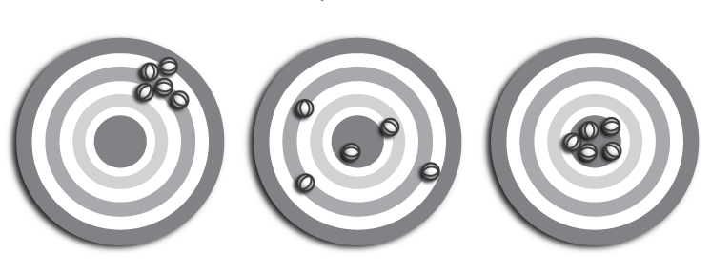
Figure 1 Figure 2 Figure 3
- Determine the accuracy and precision represented by each group of darts in the figures above. Explain your choices using complete sentences.
 | Figure 1 | Figure 2 | Figure 3
Precision?
Accuracy?

- A basketball player shoots 100 free-throws; she makes 50 of them; 25 hit the rim and bounce off and 25 miss the rim entirely. Describe the precision and accuracy of the free-throws.

- The same player is having an off day (or is she?); she sinks 20, the other 80 hit the front of the rim and bounce off. Describe the precision and accuracy of the throws.

- Two days later the player take 100 more shots, hitting 95 of her 100 shots. Reflecting on her shooting display she realizes she while she sunk 95 shots not one took the same path through the hoop. Describe the precision and accuracy of the free-throws.

- How accurately or precisely can the following be measured?

