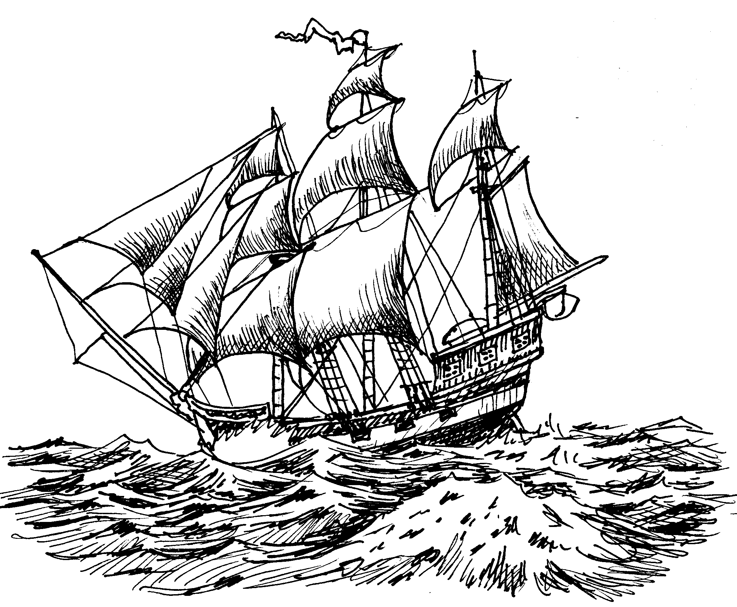
AP Physics – Intro to Waves

It’s time to build on the energy thing and keep the excitement moving along. This will surely happen with our next topic – WAVES. Waves turn out to be one of the ways that energy can be transferred from one place to another.

Out at sea, the waves roll on.

Waves ≡ disturbances that travel through space transferring energy from one place to another.

Sound, light, and the ocean's surf are all examples of waves.

A wave is a disturbance that travels through space, but what do that mean?

There are two species of waves, mechanical waves and electromagnetic waves. Mechanical waves require a medium that the wave will then travel through, or rather, the disturbance will travel through. Electromagnetic waves do not require a medium. The disturbance that travels is a changing magnetic and electric field (both of which you, lucky student, will get to study in the near future). We’ll examine these waves later on in the course.

A key concept here is that the only things that moves is the disturbance. The medium itself does not move.

That waves carry energy should be obvious. Picture the waves on the ocean. Waves are generated far out at sea mainly by the wind. The wave travels through the water for hundreds or even thousands of miles. Finally it reaches the shore where the waves pound against the beach. They have enough energy to break down the coastline and erode away continents.

Traveling Waves: The traveling wave is a sort of bump that travels through a medium. A good example of a traveling wave would be a pulse sent down a rope. Such a thing is shown in the drawing below.

Note that the rope itself does not travel, just the pulse, which is the disturbance.
You will have seen traveling waves in one of the class demonstrations on a long slinky spring.

Another type of wave is the continuous wave. Sometimes these are called wave trains. A continuous wave requires a periodic source of energy and a medium for the wave to travel through.
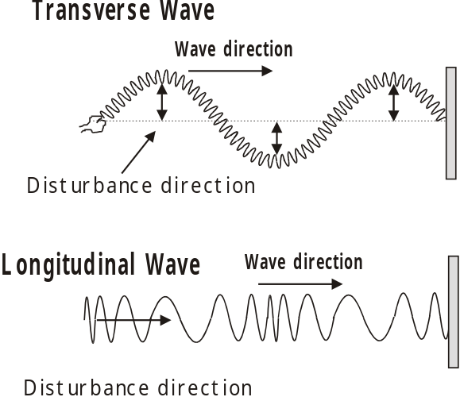

There are two types of mechanical waves, the transverse wave and the longitudinal wave.

Transverse Wave - The disturbance direction is perpendicular to the wave direction

Longitudinal Wave - The disturbance direction is parallel to the wave direction

Here are some examples of these waves:

Transverse waves – water waves, waves on a string or spring, seismic waves, and electromagnetic waves.

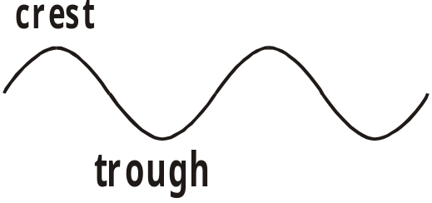
Longitudinal waves – well, the best example would be sound waves, but you saw them on springs as well.

A transverse wave is made up of a series of positive pulse and negative pulses. The positive pulses are called crests and negative pulses are called troughs. The height of the crest and the depth of the trough is of course the amplitude of the wave.

Longitudinal waves are a bit different. Basically the medium gets scrunched or pushed together and then pulled apart – stretched out The areas of increased medium density are called compressions. The compression is surrounded on either side by an area where the medium is stretched out. These areas of low medium density are called rarefactions.
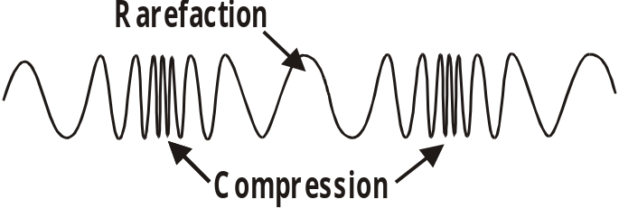

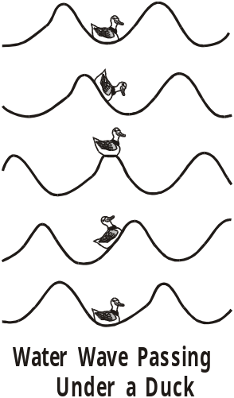
A really important, like key-type concept is that it is only the disturbance that moves, not the medium. Take you your basic water waves for example. These waves can travel hundreds of miles across the sea. But only the wave travels. The disturbance in water waves is the changing height of the water – the water goes up and it goes down. A duck sitting on the water would not be swept forward with the wave. Instead the duck would bob up as the crest of the wave passed beneath it and then the duck would go down as the trough went past. The Physics Kahuna has made a sequential type drawing of the very thing.

The frequency of a traveling wave is simply the number of cycles divided by the time they occur within (or something that sounds more scientific than that, the old Physics Kahuna is stretching – at the limits of his writing skills).

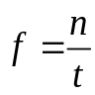

Here f is the frequency, n is the number of cycles (and has no unit) and t is the time.

- A speed boat zooms by you as you lie on your floating mattress. You find yourself bobbing up and own on the waves that the boat made. So, you decide to do a little physics experiment. You count the waves and time how long it takes for them to go past. Six wave crests go by in five seconds. So what is the frequency?

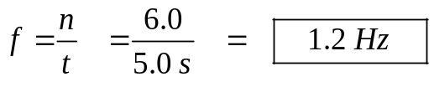

Below is the plot of a transverse wave. The displacement is plotted on the y axis and distance is plotted on the x axis. The amplitude, A, is shown. This is the maximum displacement, just as it was for periodic motion. The other thing that is shown on the graph is the wavelength, λ. The wavelength is the distance between two in phase points on the wave.

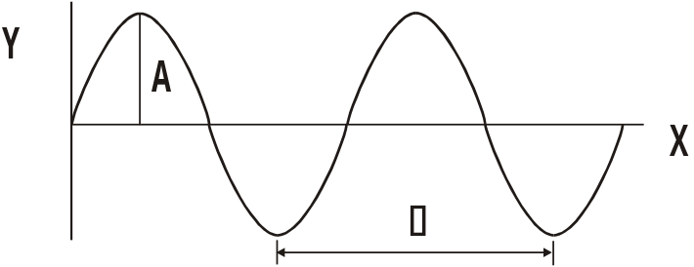
The wave is traveling at some velocity v. We know that velocity is given by this equation:

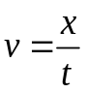

We also know that the wave travels a distance of λ in the period, T.

We can plug these into the equation for velocity:

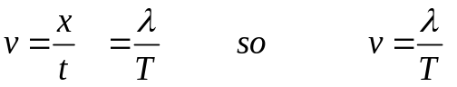

But we also know that the period is given by:

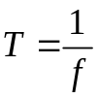 so

We can plug this in for T in the velocity equation we’ve been working on:
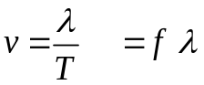

This gives us a very important equation:

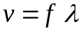

- A middle C note (notes are these musical frequency kind of deals) has a frequency of approximately 262 Hz. Its wavelength is 1.31 meters. Find the speed of sound.

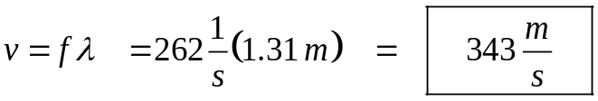

- A wave has a frequency of 25.0 Hz. Find the (a) wavelength, (b) period, (c) amplitude, and (d) velocity of wave. A graph of this wave is shown below.

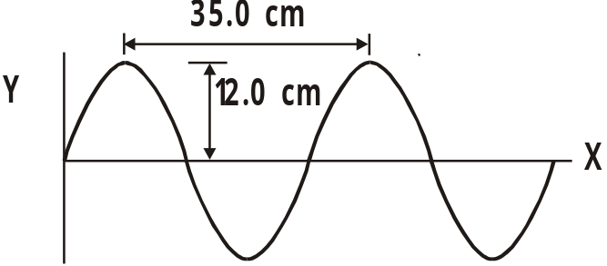
(a) Amplitude: We can read the amplitude directly from the graph: 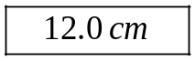

(b) Wavelength: This can be read directly from the graph as well. 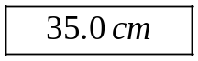

(c) Period: The period is the inverse of the frequency, which we know.

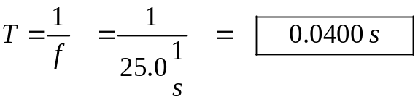
(d) Velocity: We use the wave velocity equation.

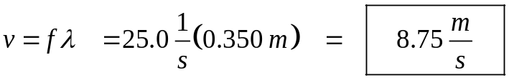

Here’s another problem.

- The speed of light is 3.00 x 10⁸ m/s. What is the wavelength for an FM radio signal broadcast at 105.3 MHz? (Note, radio waves all travel at the speed of light.)

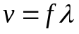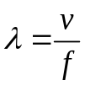
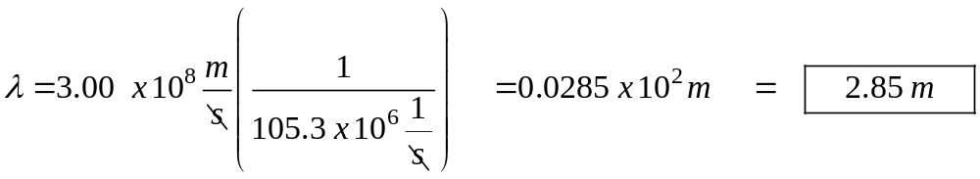

Wave Dynamics: When a wave is busy t raveling through a medium, it’s a beautiful thing. But what happens when a wave travels from one medium to another? What happens when two waves meet up? These are good questions and the answers are even better.

Reflection: When a wave traveling through a given medium encounters a new medium, two things happen: some of the energy the wave is carrying keeps going on into the new medium and some of the wave energy gets reflected back from whence it came. If the difference in the wave velocity is large, then most of the wave will be reflected. If the difference in velocity is small, most of the wave will be transmitted into the new medium. The junction of the two mediums is called a boundary.

If there is no relative motion between the two mediums, the frequency will not change on reflection. Also, and this is a key thing, the frequency does not change when the wave travels from one medium into another. It stays the same. This means that the wavelength does change.
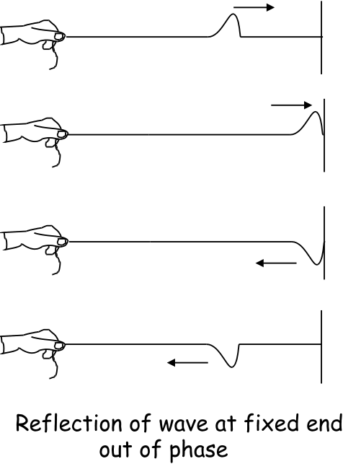
There are two types of reflection. The type of reflection depends on how the mediums at the boundary are allowed to move. The two types are: fixed end reflection, and free end reflection.

For fixed end reflection think of the medium as being constrained in its motion. In the picture to the left you see a string that is securely fixed to the wall. The string (the old medium) is free to move up and down, but at the boundary where it meets the new medium (the wall) it is constrained – the string can’t really move up and down like it could before. In fixed end reflection, the wave that is reflected back is out of phase by 180°. In the drawing you see an erect pulse traveling down the string. When it is reflected it ends up inverted. It will have the same speed going in as coming out. So in fixed end reflection an erect pulse would be reflected as an inverted pulse.

In free end reflection, the medium is free to move at the boundary. The reflected wave will be in phase. In the drawing on the right, you see an erect pulse traveling into the boundary being reflected with no phase change. The pulse went in erect and came out erect. Water waves reflecting off a solid wall are a good example of free end reflection.

Wave Speed: For a wave on a string, the speed of the wave is directly proportional to the tension in the string. Increase the tension and the wave velocity will increase.

The speed of sound waves in air is directly proportional to air temperature and directly proportional to the air density. In other words, as the temperature of the air increases, the speed of sound increases. As the density of the air increases, the speed of sound also increases. For a given air temperature, the speed of sound would be less in Gillette than it is in Orlando because the air is less dense in Gillette than in Orlando due to the greater altitude of our fair city.

Principle of Superposition: What happens when two or more waves encounter each other as they travel through the same medium? The waves can travel right through each other. As they do this, they add up algebraically to form a resultant wave.
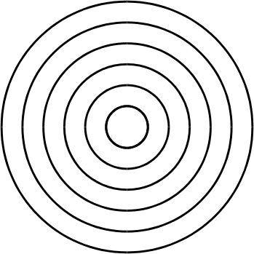
Toss a pebble in a pond and it makes a series of waves that spread out in expanding circles. You can see a drawing of the resultant wave pattern from such an event the waves travel outward in a series of expanding wave fronts. In the drawing, each of the dark lines represents a wave crest. As the wave front expands, the energy of the wave gets spread out and the wave crest decreases in amplitude. Eventually the energy is so spread out and diluted that the wave will cease to exist. This decrease in amplitude from spreading is called dampening or attenuation. This is why you couldn’t hear your mom calling you home when you were a wee tyke several blocks away.

What happens when two pebbles hit the water? Both produce waves and where the waves meet they produce interference patterns.

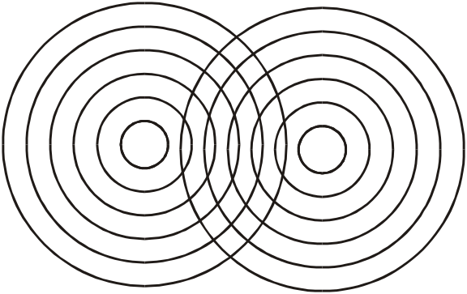
Here is a drawing showing a set of interference patterns from the two pebbles in the water deal.

These interference patterns occur where the wave crests and troughs meet each other. The interactions behave according to the law of superposition

Law of superposition ≡ when 2 or more waves meet, the resulting displacement is the algebraic sum of the individual separate wave displacements.

These interference patterns will be of great importance later on when we study light.

Basically, the waves add up or cancel each other out. Waves can add up constructively - we get constructive interference, or they can add up destructively - destructive interference.

Where two crests meet, they add up to make an even larger crest. Where a crest and a trough meet, they add up destructively - subtract from each other. So if a wave meets another wave that has the same amplitude but is out of phase (crest to trough, so to speak) they will completely cancel each other out.

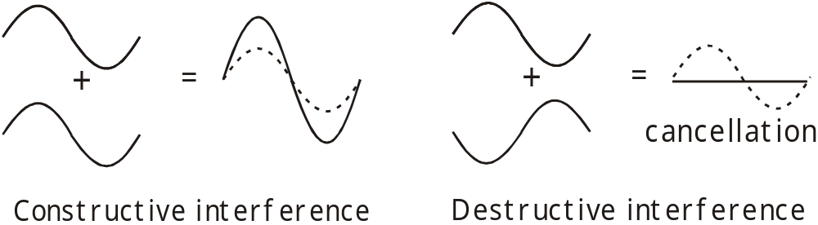

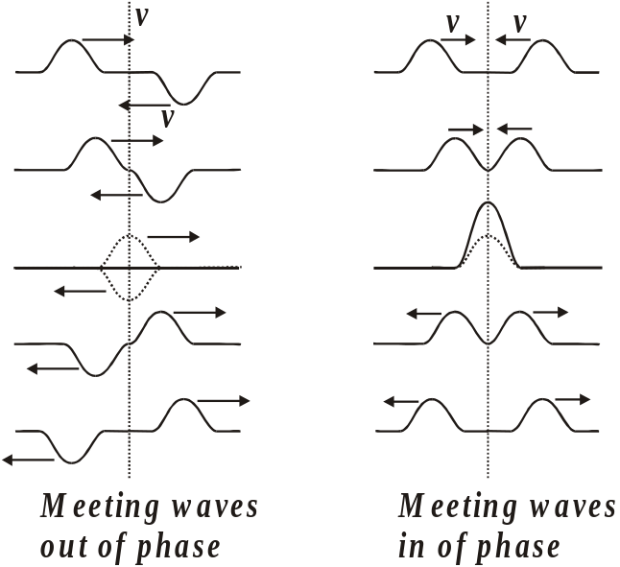
Standing waves: If you take a long, slinky spring and fix one end of it to a wall and then shake the free end you produce a pulse that travels down the spring. The pulse will be reflected when it reaches the end of the spring. This would be fixed end reflection so it would be out of phase. If you just wave the end of the spring up and down, you get a very confused, chaotic looking thing. But, if you wave the end of the spring at just the right frequency, you can produce a standing wave. You produce an incident wave that travels down the rope. If the frequency is the correct value, the incident wave and the reflected wave will alternately interfere with each other constructively and destructively. The effect is that parts of the spring will not move at all and other parts will undergo great motion.

The two waves moving in opposite directions will form a standing wave. The law of superposition acts and we get constructive and destructive interference, which forms the standing wave.

You will have observed standing waves in class with some of the demonstrations that we did. The parts of the wave that don't seem to be doing much are called the nodes and the places where the wave is undergoing maximum movement are called antinodes. The end of a string with such a wave that is attached to the wall would have to be a node, would it not?
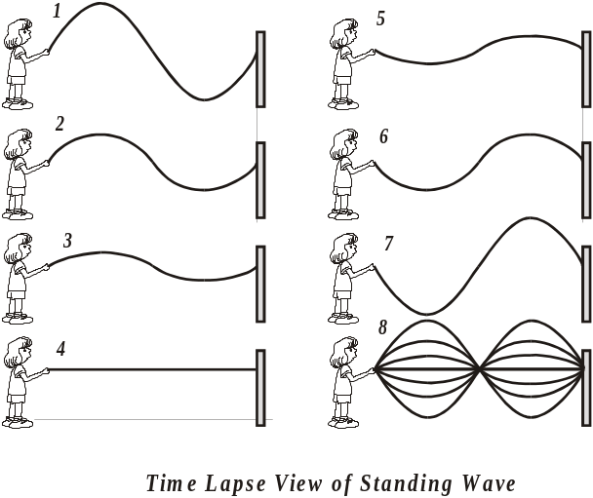
You can produce a variety of standing waves by controlling the frequency of the wave. You will have seen a delightful demonstration of standing waves in action.

Musical instruments produce standing waves. Piano strings, the interior of a tuba, a flute, and violin strings all produce standing waves. Buildings being buffeted about by the wind also have standing waves. Both transverse waves and longitudinal waves can form standing waves.

The standing wave to the left represents one half of the wavelength of the wave or ½ λ.

This would be a complete wave cycle or 2/2 λ or 1 λ.

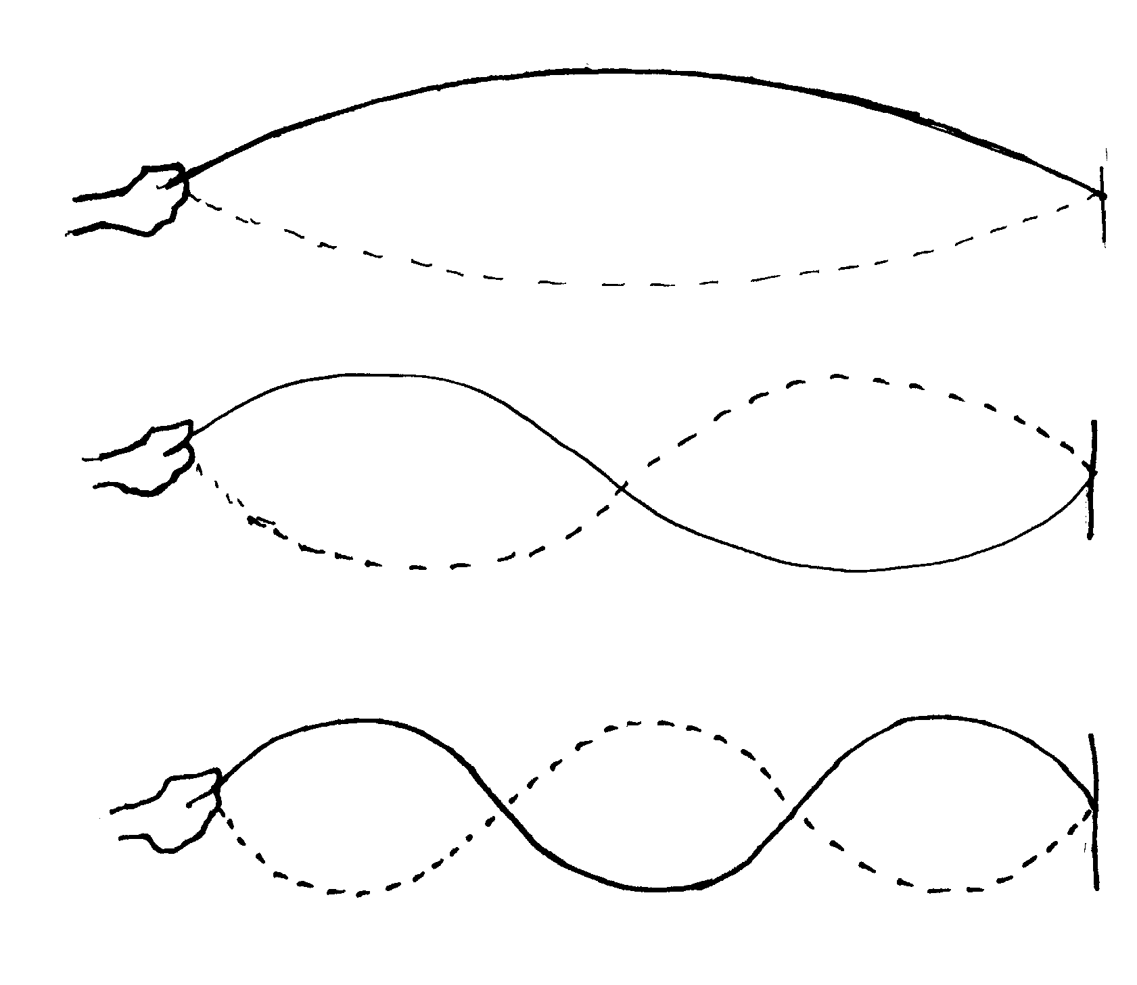
This would be 3/2 λ or 1 ½ wave.

The lowest frequency standing wave for a system is called the fundamental frequency or the first harmonic.

Fundamental Frequency ≡ Lowest frequency of vibration

Integer multiples of the fundamental frequency are called harmonics. The first harmonic is the fundamental frequency. The second harmonic is simply two times the fundamental frequency. The third harmonic is three times the fundamental harmonic. And so on.



