Introduction to Hydrostatics
DEFINING A FLUID
Matter is normally classified as being in one of three states—solid, liquid, or gaseous. Up to this point, this book’s discussion of motion and the causes of motion has dealt primarily with the behavior of solid objects. This chapter concerns the mechanics of liquids and gases.
Figure 1(a) is a photo of a liquid; Figure 1(b) shows an example of a gas. Pause for a moment and see if you can identify a common trait between them. One property they have in common is the ability to flow and to alter their shape in the process. Materials that exhibit these properties are called fluids. Solid objects are not considered to be fluids because they cannot flow and therefore have a definite shape.
Liquids have a definite volume (V is constant); gases do not (V is constant)
Even though both gases and liquids are fluids, there is a difference between them: one has a definite volume, and the other does not. Liquids, like solids, have a definite volume, but unlike solids, they do not have a definite shape. Imagine filling the tank of a lawn mower with gasoline. The gasoline, a liquid, changes its shape from that of its original container to that of the tank. If there is a gallon of gasoline in the container before you pour, there will be a gallon in the tank after you pour. Gases, on the other hand, have neither a definite volume nor a definite shape. When a gas is poured from a smaller container into a larger one, the gas not only changes its shape to fit the new container but also spreads out and changes its volume within the container.
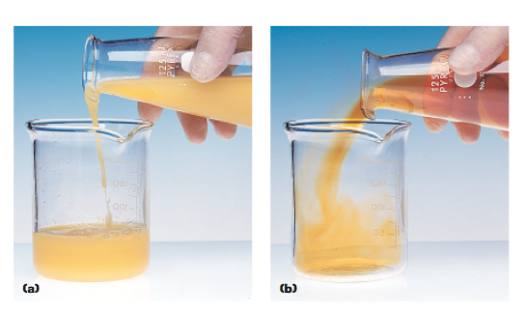
DENSITY AND BUOYANT FORCE
Have you ever felt confined in a crowded elevator? You probably felt that way because there were too many people in the elevator for the amount of space available. In other words, the density of people was too high. In general, density is a measure of a quantity in a given space. The quantity can be anything from people or trees to mass or energy.
Mass density is mass per unit volume of a substance. When the word density is used to describe a fluid, what is really being measured is the fluid’s mass density. Mass density is the mass per unit volume of a substance. It is often represented by the Greek letter r (rho).

The SI unit of mass density is kilograms per cubic meter (kg/m3). In this book we will follow the convention of using the word density to refer to mass density. Table 1 lists the densities of some fluids and a few important solids.
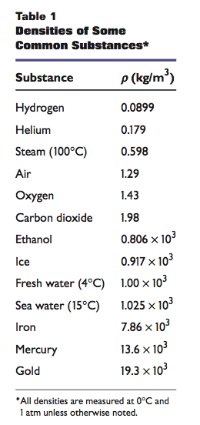
Solids and liquids tend to be almost incompressible, meaning that their density changes very little with changes in pressure. Thus, the densities listed in Table 1 for solids and liquids are approximately independent of pressure. Gases, on the other hand, are compressible and can have densities over a wide range of values. Thus, there is not a standard density for a gas, as there is for solids and liquids. The densities listed for gases in Table 1 are the values of the density at a stated temperature and pressure. For deviations of temperature and pressure from these values, the density of the gas will vary significantly.
Buoyant forces can keep objects afloat
Have you ever wondered why things feel lighter underwater than they do in air? The reason is that a fluid exerts an upward force on objects that are partially or completely submerged in it. This upward force is called a buoyant force. If you have ever rested on an air mattress in a swimming pool, you have experienced a buoyant force. The buoyant force kept you and the mattress afloat.
Because the buoyant force acts in a direction opposite the force of gravity, the net force acting on an object submerged in a fluid, such as water, is small- er than the object’s weight. Thus, the object appears to weigh less in water than it does in air. The weight of an object immersed in a fluid is the object’s apparent weight. In the case of a heavy object, such as a brick, its apparent weight is less in water than its actual weight is in air, but it may still sink in water because the buoyant force is not enough to keep it afloat.
Archimedes’ principle describes the magnitude of a buoyant force
Imagine that you submerge a brick in a container of water, as shown in Figure 2. A spout on the side of the container at the water’s surface allows water to flow out of the container. As the brick sinks, the water level rises and water flows through the spout into a smaller container. The total volume of water that collects in the smaller container is the displaced volume of water from the large container. The displaced volume of water is equal to the volume of the portion of the brick that is underwater.
The magnitude of the buoyant force acting on the brick at any given time can be calculated by using a rule known as Archimedes’ principle. This principle can be stated as follows: Any object completely or partially submerged in a fluid experiences an upward buoyant force equal in magnitude to the weight of the fluid displaced by the object. Everyone has experienced Archimedes’ principle. For example, recall that it is relatively easy to lift someone if you are both standing in a swimming pool, even if lifting that same person on dry land would be difficult.
