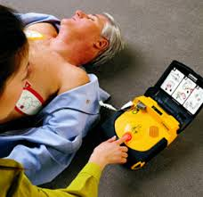
Physical Principles of Defibrillators
David J Williams Fiona J McGill Hywel M Jones

Defibrillation is the application of a pre-set electrical current across the myocardium to cause synchronous depolarization of the cardiac muscle with the aim of converting a dysrhythmia into normal sinus rhythm. Over 135,000 people die annually following acute myocardial infarction. The main cause of sudden death is ventricular fibrillation; the only effective treatment for which is early defibrillation. The defibrillator was invented in 1932 by Dr William Bennett Kouwenhoven.

Capacitors
The most important component of a defibrillator is a capacitor that stores a large amount of energy in the form of electrical charge, then releases it over a short period of time. A capacitor consists of a pair of conductors (e.g. metal plates) separated by an insulator (called a dielectric). Conductors lose and gain electrons easily, and therefore allow current to flow; whereas insulators do not lose their electrons, and hardly allow any current to flow. The maximum working voltage is the voltage that when exceeded causes the dielectric to break down and conduct, often with catastrophic results. The unit of electric charge (Q) is the coulomb (C). 1 coulomb is the quantity of electricity transported in 1 s by a current of 1 ampere (A) and is equivalent to 6.24 x 10¹⁸ electrons. Capacitance (C) is the ability to store charge. A capacitor has 1 farad of capacitance if a potential difference of 1 volt is present across its plates, when a charge of 1 coulomb is held by them (i.e. C = Q/V). Capacitors typically have values of microfarads (µF = 10^{–6} F), nanofarads (nF = 10^{–9} F) or picofarads (pF = 10^{–12} F). For a simple capacitor, the capacitance is proportional to the area over which the plates overlap (A), inversely proportional to there distance apart (d), and related to the dielectric constant (Eo). Thus C α Eo A/d.

Key formulae and definitions
Current is charge per second I = Q/t
Power is energy (or work) per second W = J/s
Power is current x potential difference W = IV
Stored charge Q = CV
Stored energy E = CV
Delivered energy E = QV/2
C, capacitance in farads; Q, charge in coulombs; V, potential difference in volts; J, energy (or work) in joules; W, power in watts; A, current in amperes
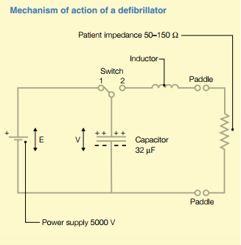
So… How does it work?
The figure to the right shows a defibrillator. When the switch is in Position 1, direct current (DC) from the power supply is applied to the capacitor. Electrons flow from the upper plate to the positive terminal of the power supply and from the negative terminal of the power supply to the lower plate. Therefore current flows and a charge begins to build up on each electrode of the capacitor, with the lower plate becoming increasingly negatively charged, and the upper plate increasingly positively charged. As the charge builds up on the plates, it creates a potential difference across the plates (V), which opposes the electromagnetic force of the power supply (emf). Initially when there is no charge on the plates, V is zero and it is easy to move electrons onto the plates. As V increases, however, it opposes further movement of electrons, and increasing work must be done to move more electrons onto the plates. The work done (W) to move charge (Q) through a potential difference V is: W = VQ. Charging a capacitor is therefore an exponential process, with a time constant determined by the capacitance and the resistance of the circuit through which the current flows. When V equals emf, the current ceases to flow and the capacitor is fully charged. For this example, calculate the amount of charge stored

Stored Charge (Q = CV) is 32 µF x 5000 V = 160 mC.

Work must be done against the field to store charge in the capacitor. The charged capacitor is therefore a store of potential lenergy, which may be released on discharge. Theoretically, the amount of energy stored in a capacitor is CV. When the paddles are applied to the patient’s chest and the switch is moved to position 2, a circuit is completed. Electrons stored on the lower (negative) plate of the capacitor are able to pass through the patient and back to the upper plate. Thus, current flows, stored electrical energy is released, and the potential difference across the plates (V) falls to zero (i.e. the capacitor is discharged).

Calculate the amount of energy delivered to the patient:

Energy (E) = QV/2). Thus, 1⁄2 x 0.160 C x 5000 V. = 400 J

Note: The apparent loss of half of the stored charge on discharge is due to circuit resistance and radiation.

