The Gravitational Analogy Revisited
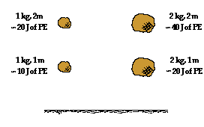
A gravitational field exists about the Earth that exerts gravitational influences upon all masses located in the space surrounding it. Moving an object upward against the gravitational field increases its gravitational potential energy. An object moving downward within the gravitational field would lose gravitational potential energy. When gravitational potential energy was introduced in, it was defined as the energy stored in an object due to its vertical position above the Earth. The amount of gravitational potential energy stored in an object depended upon the amount of mass the object possessed and the amount of height to which it was raised. Gravitational potential energy depended upon object mass and object height. An object with twice the mass would have twice the potential energy and an object with twice the height would have twice the potential energy. It is common to refer to high positions as high potential energy locations. A glance at the diagram at the right reveals the fallacy of such a statement. Observe that the 1 kg mass held at a height of 2 meters has the same potential energy as a 2 kg mass held at a height of 1 meter. Potential energy depends upon more than just location; it also depends upon mass. In this sense, gravitational potential energy depends upon at least two types of quantities:
1) Mass - a property of the object experiencing the gravitational field, and
2) Height - the location within the gravitational field
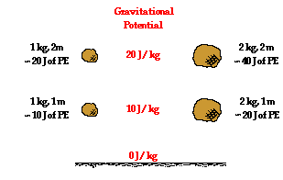
So it is improper to refer to high positions within Earth's gravitational field as high potential energy positions. But is there a quantity that could be used to rate such heights as having great potential of providing large quantities of potential energy to masses that are located there? Yes! While not discussed during the unit on gravitation, it would have been possible to introduce a quantity known as gravitational potential - the potential energy per kilogram. Gravitational potential would be a quantity that could be used to rate various locations about the surface of the Earth in terms of how much potential energy each kilogram of mass would possess when placed there. The quantity of gravitational potential is defined as the PE/mass. Since both the numerator and the denominator of PE/mass are proportional to the object's mass, the expression becomes mass independent of the object. Gravitational potential is a location-dependent quantity that is independent of the mass of the object experiencing the field. Gravitational potential describes the affects of a gravitational field upon objects that are placed at various locations within it.
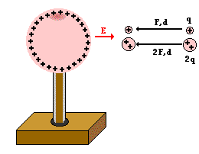
If gravitational potential is a means of rating various locations within a gravitational field in terms of the amount of potential energy per unit of mass, then the concept of electric potential must have a similar meaning. Consider the electric field created by a positively charged Van de Graaff generator. The direction of the electric field is in the direction that a positive test charge would be pushed; in this case, the direction is outward away from the Van de Graaff sphere. Work would be required to move a positive test charge towards the sphere against the electric field. The amount of force involved in doing the work is dependent upon the amount of charge being moved (according to Coulomb's law of electric force). The greater the charge on the test charge, the greater the repulsive force and the more work that would have to be done on it to move it the same distance. If two objects of different charge - with one being twice the charge of the other - are moved the same distance into the electric field, then the object with twice the charge would require twice the force and thus twice the amount of work. This work would change the potential energy by an amount that is equal to the amount of work done. Thus, the electric potential energy is dependent upon the amount of charge on the object experiencing the field and upon the location within the field. Just like gravitational potential energy, electric potential energy is dependent upon at least two types of quantities:
1) Electric charge - a property of the object experiencing the electrical field, and
2) Distance from source - the location within the electric field
While electric potential energy has a dependency upon the charge of the object experiencing the electric field, electric potential is purely location dependent. Electric potential is the potential energy per charge.
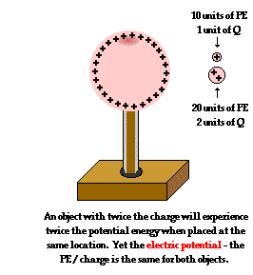
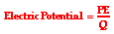
The concept of electric potential is used to express the affect of an electric field of a source in terms of the location within the electric field. A test charge with twice the quantity of charge would possess twice the potential energy at a given location; yet its electric potential at that location would be the same as any other test charge. A positive test charge would be at a high electric potential when held close to a positive source charge and at a lower electric potential when held further away. In this sense, electric potential becomes simply a property of the location within an electric field. Suppose that the electric potential at a given location is 12 Joules per coulomb, then that is the electric potential of a 1 coulomb or a 2 coulomb charged object.
Electric potential is a location-dependent quantity that expresses the amount of potential energy per unit of charge at a specified location. When a Coulomb of charge (or any given amount of charge) possesses a relatively large quantity of potential energy at a given location, then that location is said to be a location of high electric potential. And similarly, if a Coulomb of charge (or any given amount of charge) possesses a relatively small quantity of potential energy at a given location, then that location is said to be a location of low electric potential.
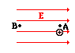
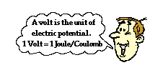
Consider the task of moving a positive test charge within a uniform electric field from location A to location B as shown in the diagram at the right. In moving the charge against the electric field from location A to location B, work will have to be done on the charge by an external force. The work done on the charge changes its potential energy to a higher value; and the amount of work that is done is equal to the change in the potential energy. As a result of this change in potential energy, there is also a difference in electric potential between locations A and B. This difference in electric potential is represented by the symbol ΔV and is formally referred to as the electric potential difference. By definition, the electric potential difference is the difference in electric potential (V) between the final and the initial location when work is done upon a charge to change its potential energy. In equation form, the electric potential difference is
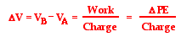
The standard metric unit on electric potential difference is the volt, abbreviated V and named in honor of Alessandro Volta. One Volt is equivalent to one Joule per Coulomb. If the electric potential difference between two locations is 1 volt, then one Coulomb of charge will gain 1 joule of potential energy when moved between those two locations. Because electric potential difference is expressed in units of volts, it is sometimes referred to as the voltage.

