Rotational Dynamics
5 – Rotational Inertia, Angular Momentum and Kinetic Energy

In the previous section we explored the _______________ of rotational motion, in this section we explore the ________________ of rotational motion.

Example:
If you open two doors with the same dimensions pushing with the same force, the first made of Balsa wood (160 kg/m³) and the second made with Black Ironwood (the densest known wood 1355 kg/m³), which door opens faster? Why?

Newton’s Second Law:

But remember in this unit we also explored ______________!

If an object is rotating in a circle _______.

Newton’s First Law: States that an object in motion will ____________ in motion.

This is related to the ______________ of the object.

Rotational Inertia (________): effectively tells us the ___________________ for objects moving in a circle to _____________ moving in a circle.

If ___________________ objects are moving in a circle we must _________ _____ __________of their Rotational Inertia’s to find the Moment of Inertia (I).

Units for moment of inertia are _________.

And because…

Mass Distribution

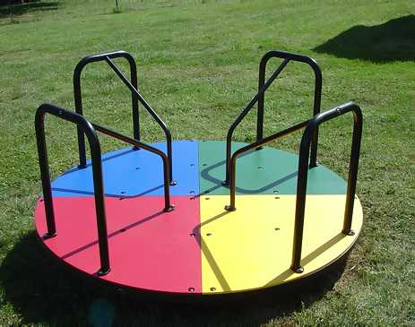
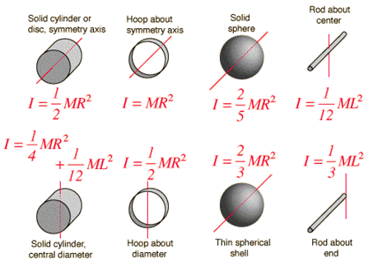
Different shapes have different ____________ _________________ and as a result have different moments of inertia.
Example:
A playground merry-go-round starts at rest and is accelerated uniformly, completing 4.00 rotations in 6.00 s.
(a) Calculate its angular acceleration.

(b) If the merry-go-round is disk-shaped, with a mass of 115 kg and a radius of 1.8 m, calculate the net torque acting on the merry-go-round.

Example:
Find the net torque required for your hip muscles to swing your leg at an angular acceleration of 5.0 rad/s², if you assume the leg is a solid rod with mass = 20 kg and length of 0.90 m.

Example:
Find the net torque required to accelerate a DVD from rest to its operating speed of 4.0 rad/s, in 2.0 seconds, if the DVD is 52 grams and has a diameter of 20. cm.

Example:
A bicycle rim has a diameter of 0.65 m and a moment of inertia (measured about its center) of 0.19 kg.m². What is the mass of the rim?

In this unit we have connected our understanding of Linear Kinematics/Dynamics to Rotational Kinematics/Dynamics. Well why stop there!?

Name: | Linear Momentum | Angular Momentum
Symbol:
Formula:
Units

Name: | Linear Impulse | Angular Impulse
Symbol:
Formula:
Units:
Example:
Suppose that a figure skater has a moment of inertia of 6.5 kg m² when her arms are outstretched and 3.8 kg m² when her arms are pulled in. She is initially spinning with an angular velocity of 8.2 rad/s with her arms outstretched and then pulls her arms in. What is her final angular velocity?

How does her does her initial rotational energy compare to her final rotational energy?
Name: | Linear Kinetic Energy | Rotational Kinetic Energy
Symbol:
Formula:
Units:
Example:

A ball is rolled down a ramp with a height of 5.0 m. What is its velocity at the bottom of the ramp?

Assumptions:
- The ball acts as a…

- The ball rolls without…

