Rotational Dynamics
4 – Rotational Kinematics

In Kinematics, we studied motion along a straight line and introduced such concepts as displacement, velocity, and acceleration. Two-Dimensional Kinematics dealt with motion in two dimensions. Projectile motion is a special case of two-dimensional kinematics in which the object is projected into the air, while being subject to the gravitational force, and lands a distance away. In the next few sections, we consider situations where the object does not land but moves in a curve.

When objects rotate about some axis, for example, when a CD (compact disc) rotates about its center each point in the object follows a circular arc.  The ________________ ____________ is the amount of rotation and is analogous to __________________ distance. We define the rotation angle ______ to be the ratio of the arc length to the radius of curvature.  Where: Δθ =  Δs =  r =  _____ = _____ revolution | 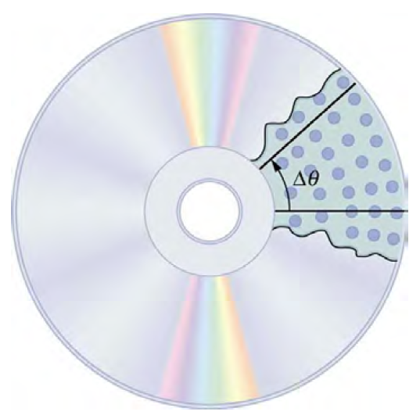

Angular Velocity (______): A measure of the rate of ________________ of the __________________ ____________________.

Note: Units for Angular Velocity are ___________________.

Example:  Calculate the angular velocity of a 0.300 m radius car tire when the car travels at about 54 km/h.  What would the angular velocity be for a car traveling at the same speed that had tires which were four times larger? | 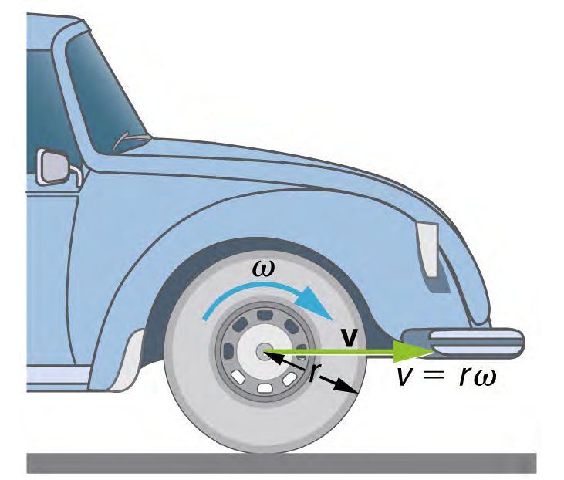
Angular Acceleration (_______): the rate of change of angular ________________________.

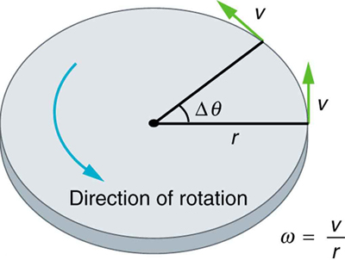

Example:  Suppose a Rockridge student puts their bicycle on a stand and starts the rear wheel spinning from rest to a final angular velocity of 250 rpm (revolutions per minute) in 5.00 s.  (a) Calculate the angular acceleration in rad/s². (Hint: how many rad’s are there in 1 revolution?) | 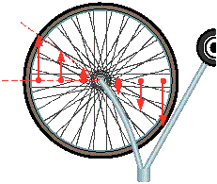
(b) If they now slam on the brakes, causing an angular acceleration of – 87.3 rad/s², how long does it take the wheel to stop?

But what about the connection between circular motion and linear motion?
In circular motion, _________ acceleration (__) occurs as the magnitude of the _________________ changes: linear acceleration is ___________________ to the motion and therefore we use _____. | 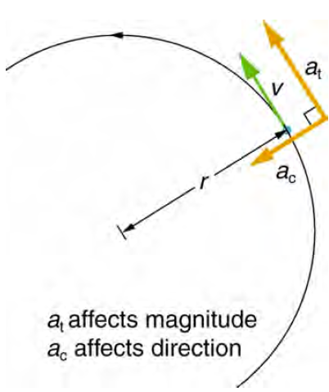
Example:  A powerful motorcycle can accelerate from 0 to 108 km/h in 4.20 s. What is the angular acceleration of its 0.320 m radius wheels? | 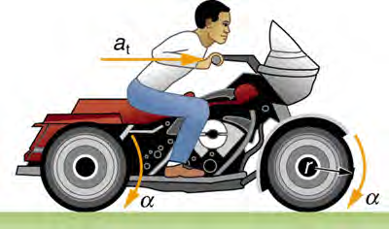
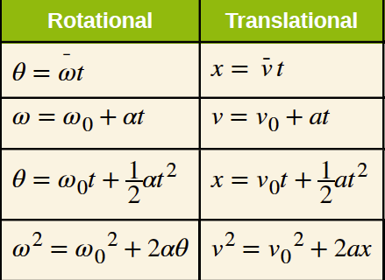
The good news is our understanding of linear kinematics allows us to explore rotational kinematics.

Example: A deep-sea fisherman hooks a big fish that swims away from the boat pulling the fishing line from his fishing reel. The whole system is initially at rest and the fishing line unwinds from the reel at a radius of 4.50 cm from its axis of rotation. The reel is given an angular acceleration of 110 rad/s² for 2.00 s.
a) What is the final angular velocity of the reel? | b) At what speed is fishing line leaving the reel after 2.00 s elapses?
c) How many revolutions does the reel make? | d) How many meters of fishing line come off the reel in this time?

