Circular Motion and Gravitation Notes
1 – Centripetal Acceleration and Force
This unit we will investigate the special case of kinematics and dynamics of objects in uniform circular motion.

Let’s determine the speed of the object.
Remember that speed is defined as: _________________________

We define the period of motion (T) as the time it takes to complete one rotation. How far does it travel in one rotation?

We can find the circumference of the circular path (distance traveled) by: ________

Therefore the speed of an object in uniform circular motion is:

First let’s consider a mass on a string being twirled in a horizontal circle at a constant speed.

Example:
A plane makes a complete circle with a radius of 3622 m in 2.10 min. What is the speed of the plane?
Ok so we’ve figured out its speed, but is the mass accelerating?

Remember that the mass is traveling at a constant speed. However, acceleration is defined as:

So how does the velocity of the mass change with respect to time?

Notice that the direction of the velocity at any time is …

So even though it may be traveling at a _________ _________ anything traveling in a circular path is _________________ because the _________________ of its velocity is always changing.

The acceleration of an object in uniform circular motion is:

Let’s do a quick derivation of this formula:

It is worth noting from the above derivation that the direction of the change in velocity is always....

Therefore the acceleration of an object in circular motion is always towards the…

This is the definition of centripetal, which means: center-seeking.

Whenever an object is accelerated there must be a…

This force is known as centripetal force, F_{c}. This is not a new force, it is simply the net force that accelerates an object towards the center of its circular path.

Examples:
- A mass is twirled in a circle at the end of a string, the centripetal force is provided by _______________________________

- When a car rounds a corner on a highway, the centripetal force is provided by _______________________________

- When the Moon orbits the Earth, the centripetal force is provided by _______________________________

Newton’s Second Law we can help us to determine a formula for centripetal force:

Example:
A car traveling at 14 m/s goes around an unbanked curve in the road that has a radius of 96 m. What is its centripetal acceleration?

What is the minimum coefficient of friction between the road and the car’s tires?
Example:
a. A skater travels at 2.0 m/s in a circle of radius 4.0 m. What is her centripetal acceleration?

b. What is the centripetal acceleration of the Moon towards Earth?

One last note on a little thing called centrifugal force. While centripetal means center-___________________ centrifugal means center- _______________________.

An inertial frame of reference is a one where Newton’s Law’s ________ ____________.
In an inertial frame of reference, centrifugal force is actually an apparent force - it does not exist. It is simply the apparent force that causes a revolving or rotating object to move in a straight line.

However, Newton’s First Law tells us that we do not need a force to keep an object moving in a straight line, you only need a force to deflect an object from moving in a straight line.

Example:
When riding in the backseat of a car that is turning a corner, you slide across the seat, seeming to accelerate outwards, away from the center of the turning circle.
Explain why the force in this case is actually working towards the center of the turn and not outwards.

Circular Motion and Gravitation Notes
2 – More Centripetal Problems
We have already seen the forces acting on a mass moving in a horizontal circle, now let’s see how this differs from a mass moving in a vertical circle.

Draw the forces acting on a mass on a string being spun in a vertical circle at the top and bottom of its path.

As with any object moving in a circle there is a ______ _____________ acting on it.

This net force is a centripetal force.
Notice that at the top of its arc the Also at the bottom of the arc the
centripetal force (or net force) is: centripetal force is:

Example:
A 1.7 kg object is swung from the end of a 0.60 m string in a vertical circle. If the time of one revolution is 1.1 s, what is the tension in the string:
a) at the top?

b) at the bottom?

Example:
An object is swung in a vertical circle with a radius of 0.75 m. What is the minimum speed of the object at the top of the motion for the object to remain in circular motion?

Now suppose the mass is spun with just enough speed to keep it moving in a circular path. What is the tension in the string at the top?

We say that the mass at the peak of the arc is weightless, because the net force working on it is only ______________________. This is the same as an object in total free fall.

Notice that the velocity of the object…

it depends only on…

For the special case of finding the minimum speed of an object at the top of its circular arc we can use the equation:

Banked Curves (and other 2-D Problems):
When cars travel at high speeds on highways, they do not rely solely on friction to keep the cars from sliding off the road. A greater centripetal force can exist if the turn is banked.

Consider a car traveling at a constant speed around a frictionless banked corner.

On a frictionless corner only _________ and ________ act on the car.

Note that in this case FN is larger because it both:

The sum of F_{N} and F_{g} must equal _____________________

Example
Calculate the angle at which a frictionless curve must be banked if a car is to round it safely at a speed of 22 m/s if its radius is 475 m.

Example
A 0.25 kg toy plane is attached to a string so that it flies in a horizontal circle with a radius of 0.80 m.. The string makes a 28º angle to the vertical. What is its period of rotation?

28º

Circular Motion and Gravitation Notes
3 – Gravitation
Newton discovered that gravity attracts any two objects depending on their ____________________ and their _________________________.

F_{g} is proportional to the two masses
F_{g} α

F_{g} is inversely proportional to the square of the
distance between their centers of mass
F_{g} α

or

Where:

Common Question Alert!!!
You will often see problems that ask something like this…

A satellite weighs 9000 N on Earth’s surface. How much does it weigh if its mass is tripled and its orbital radius is doubled?
Example
Calculate the force of gravity between two 75 kg students if their centers of mass are 0.95 m apart.

While we’re at it, let’s make sure we clear up another common misconception: mass vs. weight.
Mass: Weight:

Satellites in Orbit
A satellite of the Earth, such as the moon, is constantly falling. But it does not fall towards the Earth, rather it falls around the Earth. Just as if you were in an elevator that was falling towards the Earth you would feel weightless if you were on an artificial satellite falling around the Earth.
Consider the Moon:
Example: A 4500 kg Earth satellite has an orbital radius of 8.50x10⁷ m. At what speed does it travel?

Circular Motion and Gravitation Notes
4 – Gravitational Fields
To help imagine how these fields work, consider a campfire. It seems as though the fire is emitting a heat field.

As you approach the fire the …

As you increase the size of the fire the …

Scientists had difficulty explaining how two objects that are not in contact can exert a force on one another. In order to help conceptualize how this can occur, we had invented the idea of FIELDS.

A field is defined as…

Just like this so-called heat field, gravitational fields surround any mass. Fields can be described as either vector or scalar.

While heat is measured by temperature (a scalar) its field is also scalar.
Gravitational fields are force fields and as such are ______________.

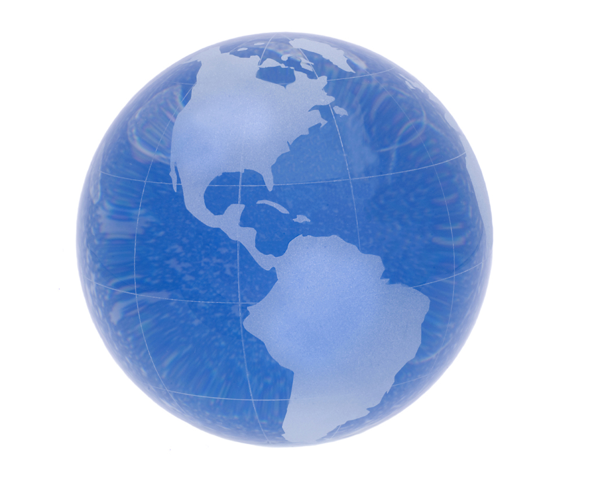

Vector fields, like vector quantities, are represented by arrows. In this case, the density of the arrows represents the magnitude of the field strength…

We are already quite familiar with gravitational field strength by its other name: ______________________.

Recall that: F_{g} = mg
Therefore

Where g = acceleration due to gravity
= gravitational field strength
= 9.80 m/s² near Earth’s surface

This formula works fine if we stay put on Earth, but it falls way short once we leave Terra Firma because…

However, we can derive a more useful formula:

Example:
A satellite orbits the Earth at a radius of 2.20x10⁷ m. What is its orbital period?

Example:
What is the gravitational field strength on the surface of the Moon?

m_{moon} = 7.35x10²² kg
r_{moon} = 1.74x10⁶ m

Geosynchronous Orbit

The orbital speed of a satellite will depend on the strength of gravitational field at the orbital radius.

Consider the following situations. Which identical satellite will be travelling faster in each case? Why?
- Satellite A orbits the Earth at twice the orbital radius of Satellite B.

- Satellite A orbits the Sun at the same orbital radius that Satellite B orbits the Earth.

The orbital period of the satellite depends only on the mass of the planet and the orbital radius of the satellite. It stands to reason therefore that at a certain orbital distance the orbital period will match the rotational period of the planet. Such a satellite is said to be in geosynchronous (or geostationary) orbit.

Example:
Find the orbital radius of a satellite that is geostationary above Earth’s equator.

What is the speed of this satellite?

Circular Motion and Gravitation Notes
5 – Potential Energy, Satellites and Escape Velocity
Gravitational Potential Energy
We have already discussed gravitational potential energy.
E_{p} =

However, as we have seen, g is not a constant but rather depends on __________________________ and ___________________________.

Let’s Derive!!!
g = ___________ and E_{p} =

If you look at your formula sheet you will notice that this equation has a negative sign. What’s the deal?

Whenever we talk about gravitational potential energy, we have to use a reference point. At this reference point we assign a gravitational potential energy of _________________.

When determining the potential energy on a mass provided by the gravitational force generated by a second mass, we assign the ZERO reference point when the distance between the objects is ____________

This means whenever the objects get closer together the potential energy between them gets less. Compared to infinity the potential energy of the object will always be negative.

Let’s sketch a graph showing the relationship between gravitational potential energy of one object relative to another and the distances between their centers.

Example:
A 2500 kg satellite is in orbit 3.60x10⁷ m above the Earth’s surface. What is the gravitational potential energy of the satellite due to the gravitational force due to the Earth?
Note: The potential energy of this satellite relative to some infinite position is…

Example cont:
What is the total energy of the satellite in the last question?
The funny thing about satellites…

Change in Potential Energy
A change in potential energy can be found by using:

∆E_{p} = E_{pf} – E_{pi}

Example:
How much work is required to move a 4500 kg Earth satellite from an orbital radius of 1.8x10⁷ m to a radius of 4.2x10⁷ m?

Example:
The International Space Station drops a 250 kg waste shuttle from an altitude of 3.50x10⁵ m. At what speed would it impact Earth if there were no air friction? (Assume it starts at rest)

Example: A 2.35x10¹⁶ kg asteroid falls towards the Earth from a really, really, REALLY far way away. How much energy is released when it impacts with the Earth?

Launching (Escape Velocity)
What goes up must come down, unless we throw it really, REALLY hard.

Escape velocity is the minimum speed an object requires in order to break free from Earth’s pull and achieve orbit. It should stand to reason that if an object is going to be completely freed from the Earth gravitational pull that we need to supply it with enough ________________________________ to match its ______________________________________ at infinite.

In terms of equations this means that:

=

Example:
At what speed do you need to throw a 1.0 kg rock in order for it to leave the Earth’s gravitational pull?

Does the mass of the rock matter?

Circular Motion and Gravitation Notes
6 – Kepler’s Laws

Johannes Kepler was a German born mathematician famous for taking the precise measurements of Danish astronomer Tycho Brahe and developing 3 laws of planetary motion around the sun. Amazingly Brahe collected ALL his precise data without the aid of a telescope!
- Each planet orbits the Sun in an elliptical path, with the Sun as one of the two foci in the ellipse.
- Areas carved out by the movement of the planet around the Sun are equal over equal time intervals (T₁ to T₂)

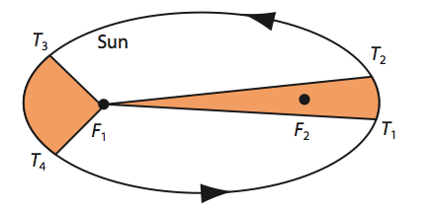

- Derive Kepler’s 3rd Law from the graph below!

_________________________________________________________________

Goal: Determine Kepler’s Third Law from the Graph below!

