**Electrostatics Notes**

1 – Charges and Coulomb’s Law

* Matter is made of particles which are ________________ or ______________ charged.
* The unit of charge is the __________________ ( )
* Charges are ________________, meaning that they cannot be…

It is thought that the total charge of the entire universe is constant and neutral.

* Charges are also ____________, meaning that they occur in finite packages.

The smallest unit of charge is called the _________________ _______________ which is equal to the charge on one proton (+) or one electron (-).

Coulomb determined that the force between two charged objects is proportional to their charges   
and inversely proportional to the square of their distances or:

Where: q1 =

q2 =

r =

k =

There are four important things to notice from this equation.

* ________________________________________________________________
* ________________________________________________________________
* ________________________________________________________________
* ________________________________________________________________

There is a very important difference between gravitational and electrostatic forces:

Gravity ALWAYS…

Electrostatic force can…

When solving for electrostatic forces we will NOT…

Instead we will determine the direction of the force based on…

Example:

Two point charges of 1.8x10-6 C and 2.4x10-6 C produce a force of 2.2x10-3 N on each other. How far apart are these two charges?

Example:

Two 85 kg students are 1.0 m apart. What is the gravitational force between them?

If these two students each have a charge of 2.0x10-3 C, what is the electrostatic force between them?

Example:

A charge of 1.7x10-6 C is placed 2.0x10-2 m from a charge of 2.5x10-6 C and 3.5x10-2 m from a charge of -2.0x10-6 as shown.

What is the net electric force on the 1.7x10-6 charge?

1.7x10-6 C

2.5x10-6 C

-2.0x10-6 C

**Electrostatics Notes**

2 – Electric Field on a Single Charge

There are many similarities between **gravitational** and *electrostatic* forces. One such similarity is that both forces can be exerted on objects that are not in contact.

In the same way that any mass is surrounded by a **gravitational field**, we will imagine that any charged object is surrounded by an **electric field**.

Similar to gravitational fields, an electric field will depend on:

_____________________ and ______________________ the charge.

In fact we define an electric field as the force per unit charge:

Where: E =

FE =

q =

We can substitute in Coloumb’s Law to get:

In the case of electric fields we are dealing with another example of a ______________ ________________.

Therefore the field is a ____________________ ___________________.

In order to show this we always draw the field lines as ______________.

Again there is an important difference between gravitational fields and electric fields due to the fact that…

We therefore define the direction of an electric field as…

Example:

What is the electric field strength at a point where a -2.00 uC charge experiences an electric force of 5.30x10-4 N?

Example:

At a distance of 7.50x10-1 m from a small charged object the electric field strength is 2.10x104 N/C. At what distance from this same object would the electric field strength be 4.20x104 N/C?

3 – Electric Field from Multiple Charges

We have already seen how charged particles emit electric fields, but how do these fields interact when two or more charges act on each other?

Consider two positively charged particles: Now, two negatively charged particles:

Note that the electric field lines point _________ _____________ _______________. Because this electric field is a force field, it is a vector. So when multiple fields overlap we simply ____________

OK, now try two opposite charges:

Again the two fields interact, only this time they_________________________

Example:

Two 5.25 uC charges are 0.40 m apart. What is the strength of the electric field between them at a point 0.10 m away from the first charge and 0.30 m away from the second?

Example:

What is the strength of an electric field midway between a 2.00 uC charge and a -4.00 uC that are 0.60 m apart?

Example:

Find the magnitude and direction of the electric field at the point P due to the charges as shown.

6.0 m

4.5 m

**P**

Suppose that a proton was placed at point P. What would its initial acceleration be?

**Electrostatics Notes**

4 – Electric Potential and Electric Potential Energy and Changes in Energy

First let’s examine **electric potential energy**. If a charged object is in an electric field it has electric potential energy - that is it has the potential to move in that field. Note that the potential energy it has could be used to…

A non-uniform field, such as that provided by a point, is one which has a different…

In this case we can derive a formula for the electric potential energy in a NON-UNIFORM FIELD:

Again note the similarities between…

Example:

How much work must be done to bring a 4.0 uC charged object to within 1.0 m of a 6.0 uC charged object from a long way away?

NOTE:

1. Potential energy is a …
2. We **WILL** …

In this case, bringing a positive charge near another positive charge requires ______________ therefore the work is ____________________.

Example:

How much work is done when a -7.0 uC charged object is brought to within 0.5 m of a 5.0 uC charged object from a long way away?

In this case, bringing a negative charge near a positive charge ______________________ energy therefore work is _____________________.

Changes in Energy

A 4.0 x10-9 C charge of mass 2.4 x10-21 kg, is initially located at point **A**, 3.0 m from a stationary 6.0x10-8 C charge.

a) How much work is required, by an external agent, to move the 4.0x10-9 C charge to a point **B**, 0.50 m from the stationary charge?

b) If the 4.0x10-9 C charge is now released from point **B**, what will be its velocity when it passes back through point **A**?

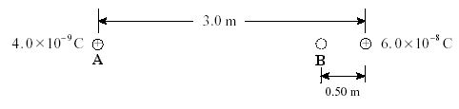

Electric Potential

Now we need to consider a new quantity, electric potential (V). Electric potential is defined as the electric potential energy per unit charge.

Which becomes,

**NOTE**:

1. The electric potential is defined in terms of the moving of a positive charge. Therefore…

+ charges…

- charges...

1. The unit for potential is…

1

2

3

**P**

5.0 cm

7.0 cm

5.0 cm

4.0 uC

40o

50o

-2.0 uC

3.0 uC

Example:

Calculate the potential at point P as shown in the diagram.

NOTE:

1. Potentials are…
2. We WILL use…

Potential Difference

We sometimes want to determine the electric potential between two points. This is known as the **potential difference**.

For example, given two points A and B, the potential difference between A and B is:

NOTE: When we talk about potential at a point we are talking about the potential difference between that point and infinity, where the potential at infinity is ZERO.

Example: What is the potential difference between points A and B due to the charge shown?

A

B

8.00 uC

1.00 m

0.50 m

**Electrostatics Notes**

5 – Equipotential Lines and Changes in Energy

Equipotential Lines

* As a charge moves along an electric field line, work is done by the electrical force. The energy gained or lost by this charge moving in the field is a form of *potential energy*, and so associated with the electric field is an *electric potential*, V, which has units of Energy per charge or Joules per Coulomb (also call Volts).
* Since voltage is potential energy per unit charge, voltage increases when going from a negative charge towards a positive charge. (The kinetic energy of a positive charge would increase when going from a higher potential to a lower potential.)
* A surface along which the potential is constant is called an *Equipotential*. On a piece of paper, the equipotential is represented by a line on which the voltage is constant.

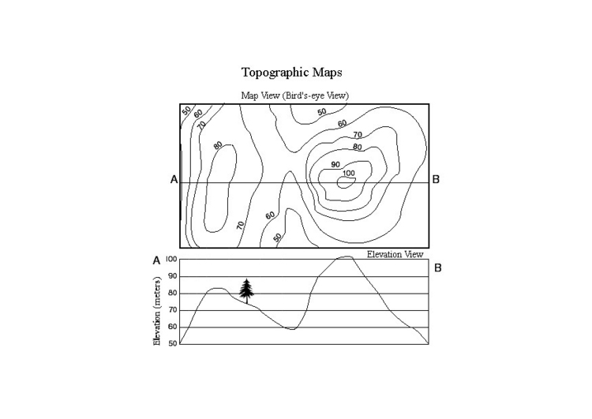

Topographical Maps:

* Since gravitational potential energy depends on height, lines of constant height would be gravitational equipotentials. A map of such lines is called a topographical map. Typically, a topographical map shows equally spaced lines of constant elevation.
* Where the lines are most closely spaced the elevation is changing most sharply, in other words the terrain is steep.

**Electrostatics Notes**

6 – Electric Potential in Uniform Electric Fields

If we examine the electric field   
between charged plates we will   
find that it is…

Notice that the density of the lines is also…

We have seen that the electric   
field surrounding a point   
charge is not uniform –   
that it…

In a uniform electric field we cannot use our previous formula:

This formula is only valid for describing the strength of non-uniform fields (point charges only!!!)

To find an equation for uniform fields, we will once again draw a parallel with gravitational potential energy.

Consider a mass sitting in a uniform *gravitational* field at some height.

The mass will tend to move from…

As it does it…

If we allow the mass to fall the work done on it (W = ) is negative. If we want to lift the mass to a certain height we need to do positive work on it.

A charged object in an electric field will behave in the same way, accelerating from an area of…

As it does it…

In the same way that we would do positive work on an object to lift it against gravity, we need to do work to bring a positive charge near a plate with positive potential.

To calculate the work done in this case we can use the formula:

W = Δ Ep = Fd

It is often easier, however, to describe the work done in a uniform field using the potential difference between the two plates.

Recall that potential difference:

∆V =

A potential difference is generated any time we have areas of high and low potential energy, just like those generated by gravitational fields.

In order to determine the electric field between two charged plates we must use the formula:

Where: E =

∆V =

d =

Example:

An electron is accelerated from rest through a potential difference of 3.00x104 V. What is the kinetic energy gained by the electron?

Example:

Calculate the electric field strength between two parallel plates that are 6.00x10-2 m apart. The potential of the top plate is 6.0 V and the bottom plate is -6.0 V.

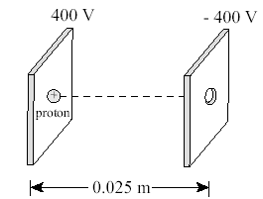

Example:

A proton, initially at rest, is released between two parallel plates as shown.

a) What is the magnitude and direction of the electric field?

b) What is the magnitude of the electrostatic force acting on the proton?

c) What is the velocity of the proton when it exits the - 400 V plate?

**Electrostatics Notes**

7 – Cathode Ray Tubes and the Millikan Oil Drop Experiment

Non-flat screen TVs and monitors work by directing a beam of high speed particles at a film of fluorescing chemicals. These charged particles are accelerated by electrically charged plates. After they are sped up, the beam can be directed by very precise control of another set of charged plates. Consider the following problem:

Example:

A beam of electrons is directed to a region between oppositely charged parallel plates as shown in the diagram below.

1) The electron beam is produced by accelerating electrons through an electric potential difference of 380 V. What is the speed of the electrons as they leave the 380 V plate?

2) What is the electrostatic force on electrons in the region between the horizontal plates when they are connected to a 9.0 V potential difference?

3) What is the acceleration of the electrons between the deflecting plates?

4) What is the final magnitude and direction of the velocity of the electrons as it leaves the second set of plates?

5) How could you cause the beam to bend

a. more?

i)

ii)

b. less?

i)

ii)

**Resistor/Capacitor (RC) Circuits Notes**

8 – Capacitors

What makes capacitors special is their ability to **______________________**; they’re like a fully charged electric battery.

|  |  |
| --- | --- |
| **Common applications of capacitors include….** | **Circuit Symbol** |
| * local energy storage * voltage spike suppression * complex signal filtering |  |

The ***capacitance*** of a capacitor tells you **______________________________**, more capacitance means more capacity to store charge.

The standard unit of capacitance is called the **__________**, which is abbreviated *____*. Now this is where things can get a little tricky.

|  |  |
| --- | --- |
| 1 Farad is a *HUGE* amount of capacitance; even 0.001F (1 milifarad – 1mF) is a big capacitor.  Usually you’ll see capacitors rated/range in the pico- (10-12) to microfarad (10-6) range. |  |
| A capacitor consists of two parallel ______________ metal plates, and _________________ (or insulating) dielectric.  The plates are made of a conductive material: ________________  _____________________________________________________  The _______________ can be made out of all sorts of insulating materials: paper, glass, rubber, ceramic, plastic, or anything that will impede the flow of current. |  |

The capacitance of a capacitor is…

Where: C =

εo =

κ =

A =

d =

|  |  |
| --- | --- |
| Example:  The plates of a parallel plate capacitor (PPC) are circular with a radius of 6.0 cm each. The separation between the plates is 2.0 mm. Determine the capacitance if the material between the plates has a dielectric constant of 1. | Example:  A parallel-plate capacitor 1.0 x 10−6 m2 in size with capacitance C = 10 pF has maximum charge. If the potential difference between the plates is 0.5 mV, determine their separation distance if the material between the plates has a dielectric constant of 1. |

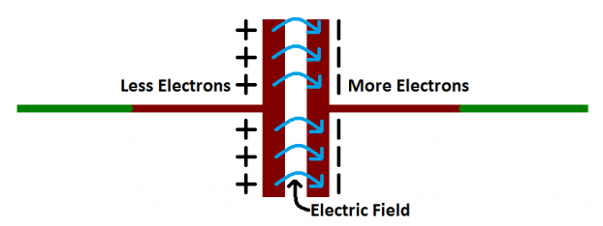*So how do these crazy things work?*

When electrons flows into a capacitor, they get “_____________” because they can’t flow through the insulating dielectric.

One plate, filled with incoming electrons, has overall ___________ charge.

This large mass of _____________ charges on one-plate forces away like charges on the other plate, giving it an overall _______________ charged.

At this point the capacitor is said to be ______________ imbalance generates a __________________________ between the plates. (*Wait… didn’t we just learn about that earlier in the unit!?!*)

At some point the capacitor plates will be so full of charges that they just ______________________________.

This is where the **capacitance** (farads) of a capacitor comes into play, which tells you the ***_________________***

***______________________________.***

To calculate Capacitance, Voltage, and Charge…..

Where: C =

Q =

V =

|  |  |
| --- | --- |
| Example:  Peter van Musschenbroek invented the first capacitor in 1745 when he and his assistant stored charge in a device called a Leyden jar. If 5.0 x 10-4 C of charge were stored in the jar over a potential difference of 10,000 V, what was the capacitance of the Leyden jar? (*When van Musschenbroek touched the jar, he received such a jolt that he exclaimed he would not try the experiment again for all the kingdom of France*) | Example:  Nancy pushes the shutter button on her camera and the flash unit releases the 4.5 x 10-3 C of charge that was stored in a 0.50 µF capacitor. What is the potential difference across the plates of the capacitor inside the flash? |

**Capacitors in series and parallel circuits** - *Remember capacitors are just components used in circuits!*

Capacitors, however, add together in a way that’s **______________________________**of resistors.

|  |  |
| --- | --- |
| **Capacitors in Series** | **Capacitors in Parallel** |
|  |  |
| Example:  Find the equivalent (*total*) capacitance of the circuit ***and*** charge at each capacitor. | |

|  |  |
| --- | --- |
| Example: A parallel-plate capacitor is connected to a battery that maintains a constant potential difference V between the plates. If the plates of the capacitor are pulled farther apart, do the following quantities increase, decrease, or remain the same?  (a) the electric field between the plates - increases/decreases/same  (b) the charge on the plates - increases/decreases/same  (c) the capacitance - increases/decreases/same  (d) the energy stored in the capacitor - increases/decreases/same | Example: Two capacitors in series are connected to a capacitor in parallel. The two capacitors in series have capacitance’s C1=10 µF, C2=5 µF, and the capacitor in parallel to both of these has a capacitance of 20 µF. Find the equivalent capacitance of this circuit and the total energy stored in the capacitors if connected to a 12-volt battery. *Draw the circuit first!* |

Capacitors Store Energy

Capacitors are essentially _________________________ placed within circuits.

As discussed previously, the purpose of capacitors is to store charge and therefore to _____________________.

The energy stored (potential energy) in a capacitor can be expressed in terms of the _____________ done by the battery.